**IE 7300 PROJECT REPORT**

***Topic:***

Predicting Bike Share Due to Weather Forecast

**Group 12:**

Vincenzo Coppola

Varun Vyas

Abhijeeta Gupta



List of figures 2

List of Tables 3

ABSTRACT 4

INTRODUCTION 4

Problem Setting 4

Problem Definition 5

DATA DESCRIPTION 6

Data Sources 6

Exploratory Data Analysis 8

Data Engineering and Exploration 8

Data Preprocessing 8

Data Validation 9

Data Engineering 11

Data Visualization 12

DATA MODEL METHODS AND RESULTS 15

Linear Regression 17

Closed Form Solution 18

Gradient Descent 21

Neural Network 27

CONCLUSION 29

# List of figures

Figure 1- Training and Validation Dataset (Hourly) 6

Figure 2- Final Testing / Alternate Training Dataset (Daily) 6

Figure 3 Data / Library Import for Project 9

Figure 4- Null Verification 10

Figure 5- Column Renaming 10

Figure 6- Overly Unique Column Removal 11

Figure 7- Outlier Removal (Unused) 11

Figure 8- count_bin: Engineered Column based on Target Quartile 12

Figure 9- Attribute Distributions 13

Figure 10- Weather and Temperature distributed showing Target 13

Figure 11- Rental Activity Hourly 14

Figure 12- Additional Visualizations on Weather and Holidays 14

Figure 13- Weather Indicators vs Total Count Regressions 15

Figure 14- Code to Create heat_index column 15

Figure 15- Correlations of Data Attributes 16

Figure 16- Linear Regression Class 18

Figure 17- Baseline Model: Overfitting 19

Figure 18- Historical Model: Utilized 19

Figure 19- Limited Data Model: Low R^2 so not useful for other data 20

Figure 20- Hold-Out Testing Results 21

Figure 21 – Gradient Descent No penalty 22

Figure 22- Stochastic GD No Penalty 23

Figure 23- Mini-Batch (.25 of data) no penalty 23

Figure 24- Batch GD with L2 Norm 24

Figure 25- Issues that can come from high lambda (lambas = .0001 .01 .00000001) 25

Figure 26- Varying the Cost Function 26

Figure 27- Training on Daily Rentals 26

Figure 28 – NN Training and Validation Loss 28

Figure 29- Prediction vs Actualas Data 28

Figure 30- Total count as training example month wise 29

# List of Tables

Table 1- Dataset Description 7

# ABSTRACT

Herein this report, the process of utilizing weather forecast data to predict bicycle rental numbers in bike share programs will be outlined. Utilizing python, a variety of Linear Regression models along with a Neural Network were devised following a detailed data cleaning and visualizing process to better understand the task at hand. The aim of the project was to evaluate the models using a variety of common data science algorithms and methods learned in class but mainly from scratch. The overarching objective was to utilize those models to determine the best way to predict bike rental counts from descriptive weather, date, and historical baseline data.

# INTRODUCTION

## Problem Setting

We only have one world and in order to maintain it, we need to make an active effort to reduce our carbon footprint. One way to do this is to make small changes in our everyday commuting to reduce our own carbon emissions. A method of doing this that has been growing in recent years is known as a Bike sharing system. These systems have been implemented over the last few decades to provide a convenient and affordable way for residents to rent bikes. The system automates the entire bike rental process by allowing members or others to pick-up, rent, and return the bike with no person-to-person contact, something that is increasingly important in the post-covid era. Users can borrow a bike from one location in a city and return it to a different location miles away. There are currently (as of 2021) around 3000 bike-sharing systems in place globally with over 9 billion bikes offered [1]. At the time of this dataset’s creation (2011-2012) the numbers were only 500 systems offering roughly 500,000 bicycles [2]. That alone shows some incredible growth in 10 years and those numbers have undoubtedly grown.

This dataset illustrates bike rental importance even in a city like Boston where one can see Blue Bike rides being utilized on a daily basis. The growth of bicycle share programs can truly be seen from the growth in these numbers and programs as aforementioned. With global warming a rising concern, this growth makes sense. Similarly, driving in large cities has many downfalls in addition to environmental concerns, including heavy traffic and causing health issues from a lack of physical exercise. Whatever the case, people should and want to ride bikes and the growing numbers prove that. That being said, it is important for bike share programs to keep up with demand which is clearly growing and to do so it is the help of data scientists’ ability to predict this demand.

## Problem Definition

This project aimed to do just that. The objective was to predict bike rental count on an hourly basis utilizing the weather and seasonal forecast (2011-2012) which provided a model that can be implemented on a larger scale moving forward. To do so, several Machine learning techniques and algorithms including multiple types of normalized and unpenalized regressions were to be implemented. The data was first cleaned and visualized to perform some manual dimensionality reduction by removing redundant columns and multicollinearity. Then, the following models were coded:

* Linear Regression
  + Closed Form Solution
  + Gradient Descent
    - Stochastic Gradient Descent
    - Mini Batch Gradient Descent
  + Norms
    - L1 (‘Lasso’)
    - L2 (‘Ridge’)
  + Cost Function
    - SSE (MSE)
    - RMSE
    - MAE
* Neural Network

Using the final prediction input x, the model(s) were trained and evaluated using a variety of metrics (including the cost functions listed above and R^2 error) on a test sample of the data.

# DATA DESCRIPTION

## Data Sources

The data for this project was provided by the Laboratory of Artificial Intelligence and Decision Support (LIAAD) at the University of Porto in Portugal. It provides information regarding Capital Bike sharing programs which aided in the project’s purpose as follows. The data is split into two csv files, one with hourly data and one with daily data. The initial goal was to devise a model for predicting hourly data. However, as will be explained in the later sections, both datasets were used. The hourly data which was intended to be used contains 17379 instances and 16 feature attributes describing the hourly count of rental shares for bikes in the Capital bikeshare system for 2011 and 2012 utilizing weather and holiday information pulled from freemeteo [3] and the dchr govt [4]. The daily dataset describes the same bikeshare rental shares however on a daily basis and therefore only contains 731 rows with the same 16 attributes.

As can be seen below, the two datasets first few rows and some descriptive statistics are shown.

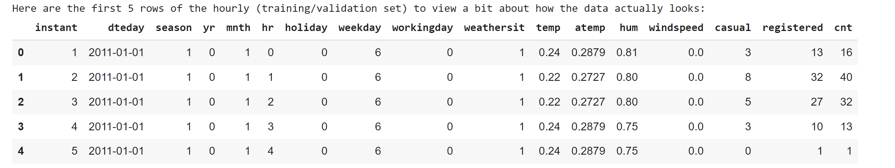

Figure 1- Training and Validation Dataset (Hourly)

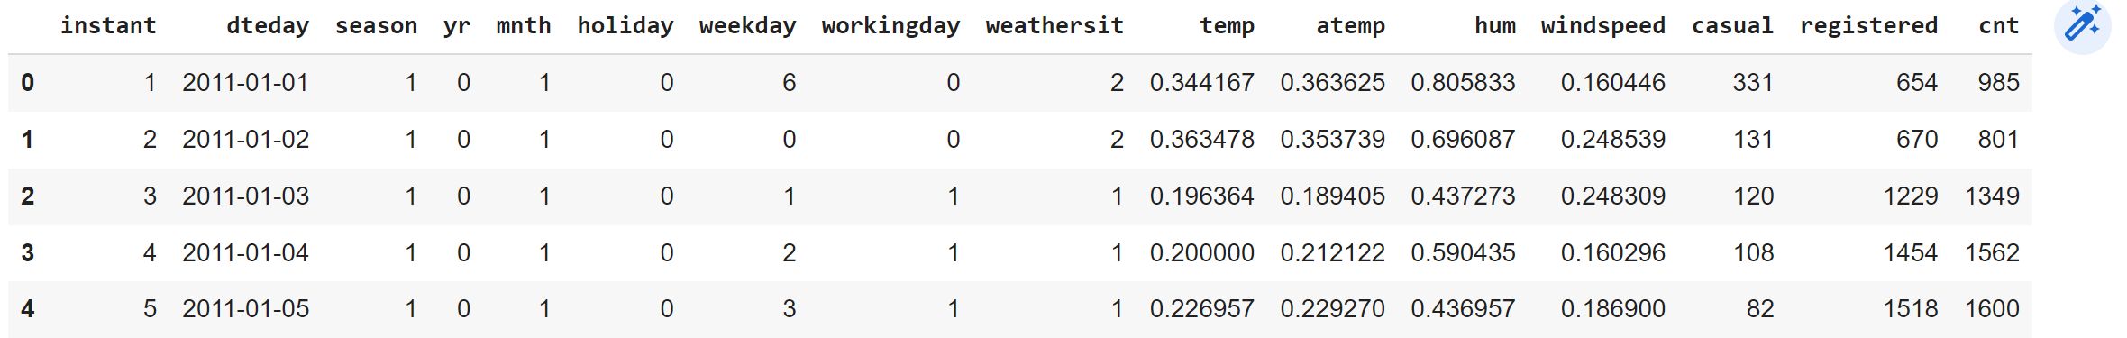

Figure 2- Final Testing / Alternate Training Dataset (Daily)

Some sources to have as references for the project can be seen below:

SOURCES:

[1] <https://www.pbsc.com/blog/2021/10/the-meddin-bike-sharing-world-map>

[2] <https://archive-beta.ics.uci.edu/dataset/275/bike+sharing+dataset>

[3] <http://www.freemeteo.com>

[4] <http://dchr.dc.gov/page/holiday-schedule>

Table 1- Dataset Description

|  |  |
| --- | --- |
| instant | Record Index |
| dteday | Date |
| season | Season  1: winter, 2: spring, 3: summer, 4: fall |
| yr | Year  0: 2011, 1:2012 |
| mnth | Month  1 to 12 from January |
| hr | Hour (Only in hourly dataset)  0 to 23 from midnight |
| holiday | Whether the day is a holiday or not (extracted from [Web Link]) |
| weekday | Day of the week  0 to 6 from Sunday |
| workingday | If day is neither weekend nor holiday is 1, otherwise is 0 |
| weathersit | Description of weather  1: Clear, Few clouds, Partly cloudy, Partly cloudy  2: Mist + Cloudy, Mist + Broken clouds, Mist + Few clouds, Mist  3: Light Snow, Light Rain + Thunderstorm + Scattered clouds, Light Rain + Scattered clouds  4: Heavy Rain + Ice Pallets + Thunderstorm + Mist, Snow + Fog |
| temp | Normalized temperature in Celsius  The values are derived via (t-t_min)/(t_maxt_min), t_min=-8, t_max=+39 (only in hourly scale) |
| atemp | Normalized feeling temperature in Celsius  The values are derived via (tt_min)/(t_max-t_min), t_min=-16, t_max=+50 (only in hourly scale) |
| hum | Normalized humidity. The values are divided to 100 (max) |
| windspeed | Normalized wind speed. The values are divided to 67 (max) |
| casual | Count of casual (unregistered or guest users |
| registered | Count of registered users |
| cnt | TARGET - Count of total rental bikes including both casual and registered |

# Exploratory Data Analysis

Garbage in = Garbage out as many are familiar with. To ensure that the models being developed in this project provided trustworthy results, the data had to be cleaned and engineered first. A variety of checks were completed to ensure this was the case as will be described in the section that follows and many visualizations were created to have a better understanding of the data being worked with and to give reason to the decisions made in the modelling process.

## Data Engineering and Exploration

With properly explored and well understood data, predictions become much easier and more efficient due to a variety of reasons. In this project as in many projects, the exploration and modelling processes were not independent of each other or linear. Rather, the processes were intertwined, cyclical and what you could consider an agile developing process. Oftentimes as data was explored and fed into the later discussed models several imperfections in the original process could be discovered and then fixed to improve the predictive process. Some of this process can be seen as outlined below:

## Data Preprocessing

Data Preprocessing in this project is defined by the following steps which will be elaborated on.

* Data Validation
* Data Engineering
* Data Visualization

First, all necessary libraries for visualizing and data engineering were imported (none for modelling!). Note – to run code file paths must ofcourse be changed to your local downloads.

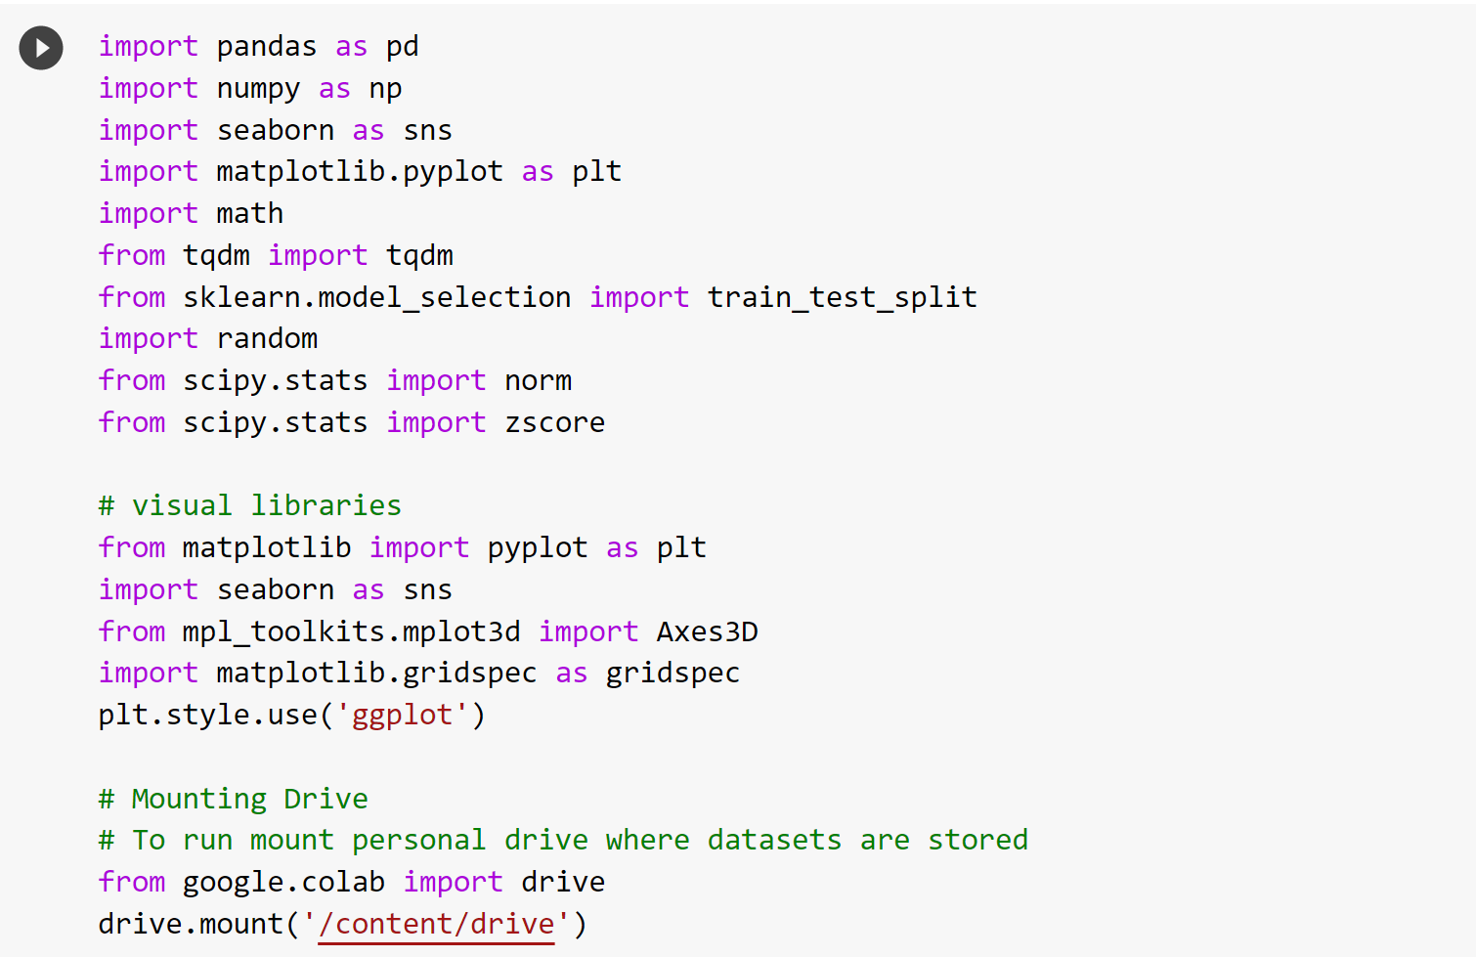

Figure 3 Data / Library Import for Project

### Data Validation

To validate the data, we first checked for missing values in the dataset. Below in Figure 4, the check for null values was completed and fortunately the dataset had no null values which required handling.

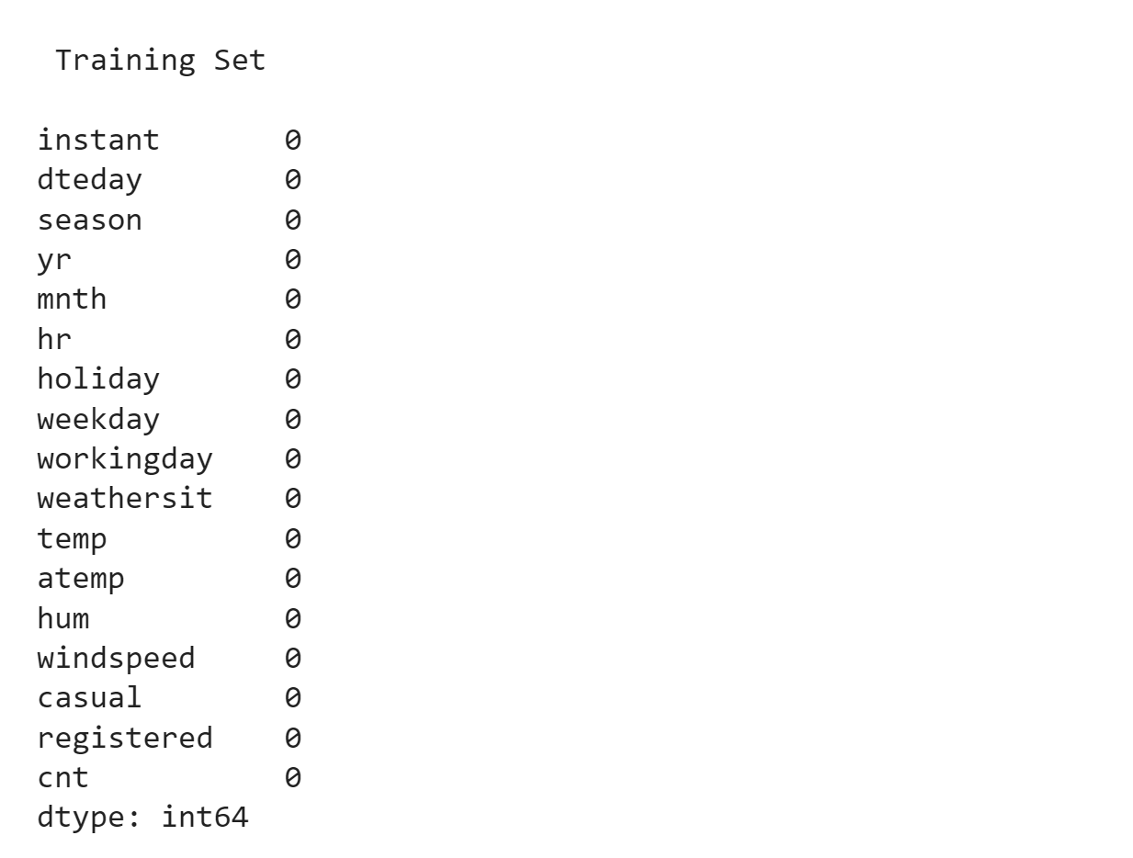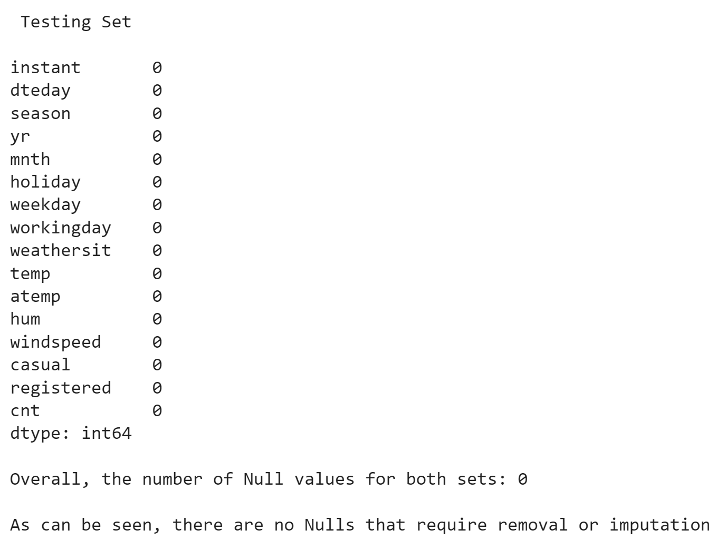



Figure 4- Null Verification

The next step of data validation was to clean up and remove ambiguity from some of the given column names. This was done from the code seen below.

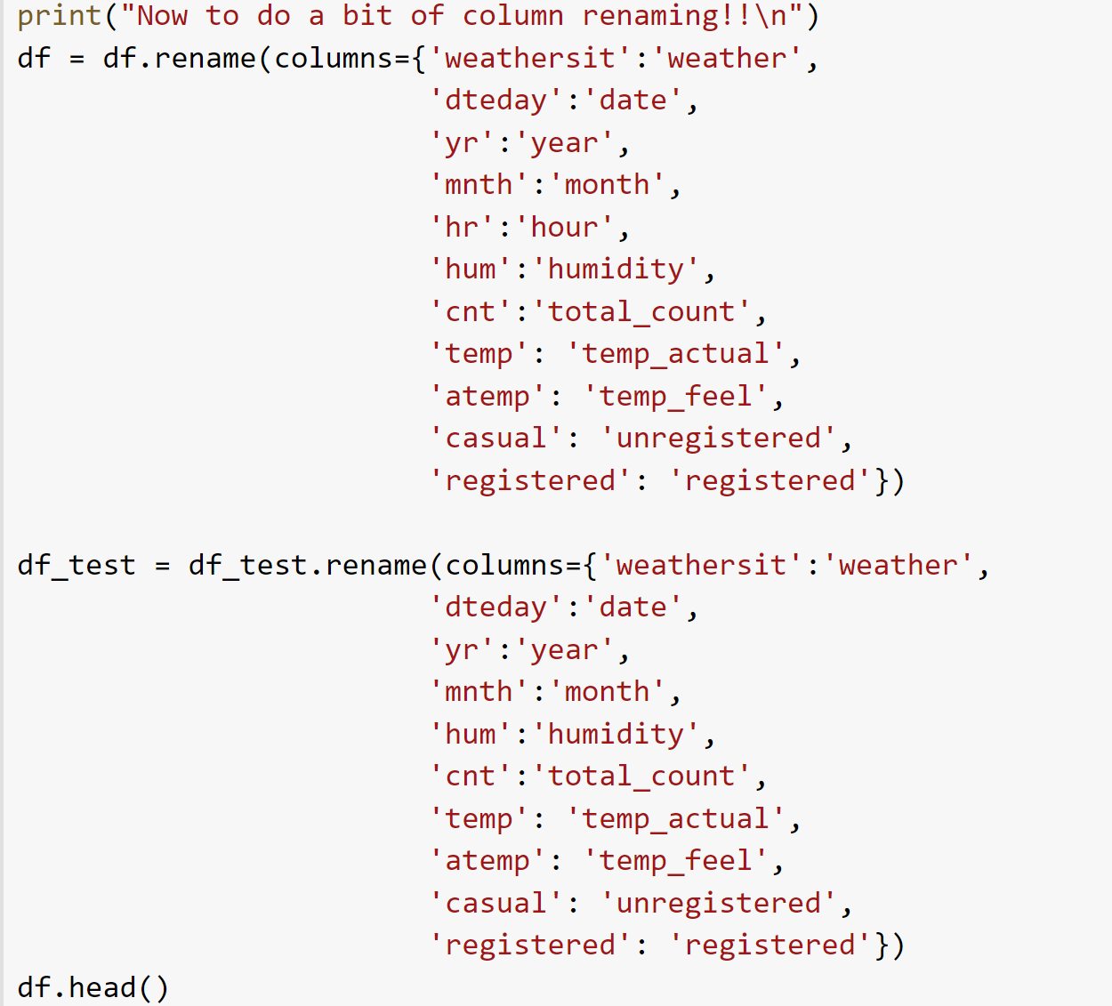

Figure 5- Column Renaming

### Data Engineering

After validating and cleaning some of the column names to provide a bit of clarity on the dataset, the engineering process started. First, we looked to remove any column which was overly unique as when predicting these columns would provide no value to the models. This was done as can be seen below:

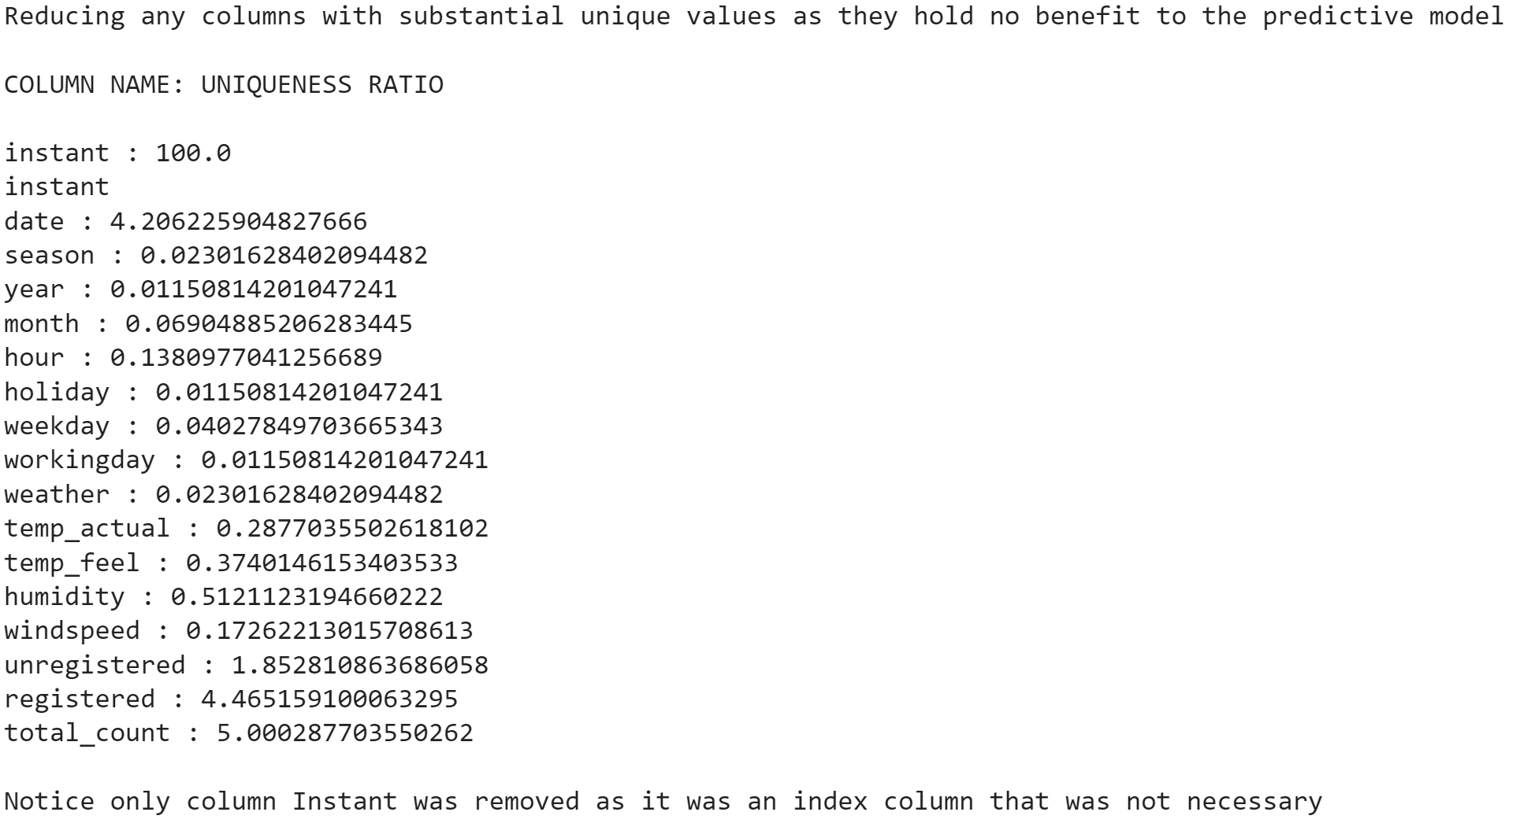

Figure 6- Overly Unique Column Removal

Fortunately, the only unnecessary column in the data was the instant column which was essentially acting as an index and was removed. Outlier removal was coded however after considering real world weather data, it was thought best to leave all available data as it can be hard to determine if something like a storm or heat wave should really be considered an outlier or if it is a naturally occuring event since the real world can be so random.

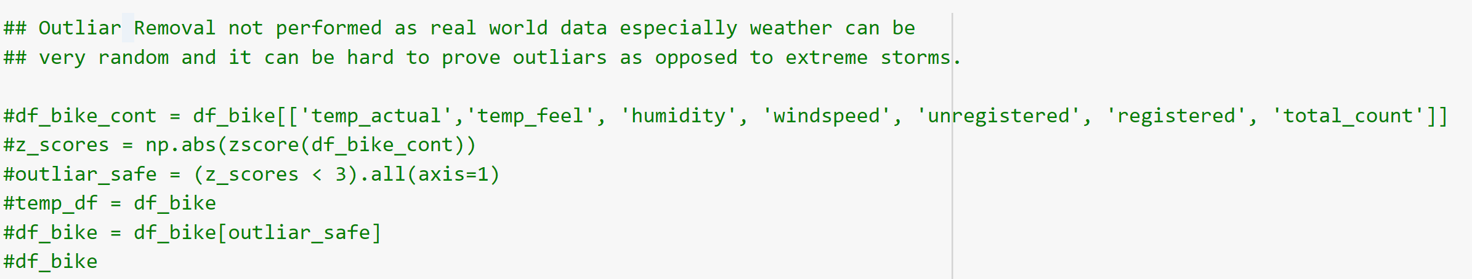

Figure 7- Outlier Removal (Unused)

After some data cleaning came the process of data engineering. First the target variable was discretized into bins based on the quartiles of the data to later help in visualizing the data. This was done for both datasets however only the hourly set code can be seen below:

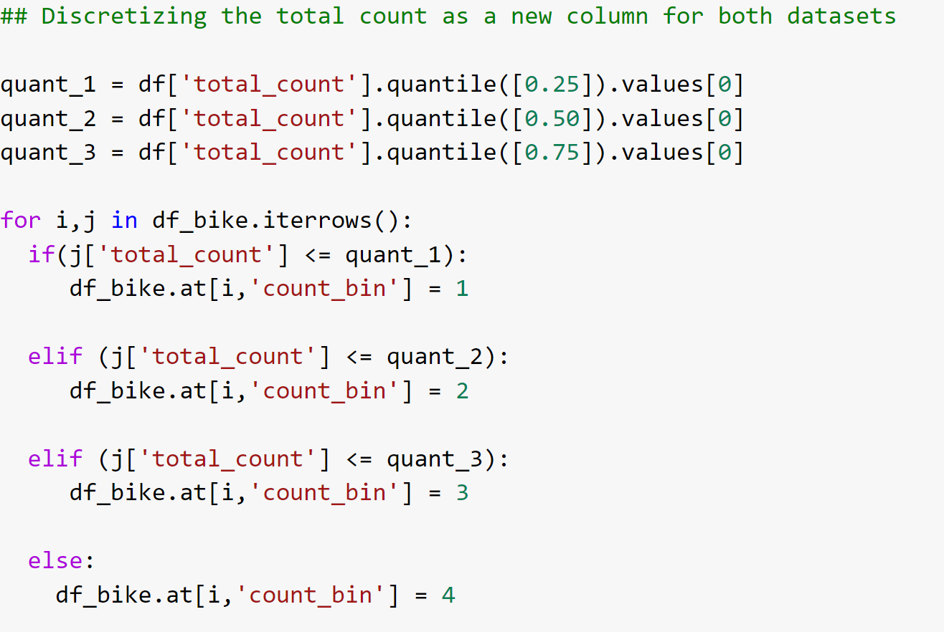

Figure 8- count_bin: Engineered Column based on Target Quartile

As can be seen, a great deal of feature engineering was completed to this point however more was completed later including a column called heat_index. This is due to the aformentioned agile approach took for the project.

### Data Visualization

Now it was time to better understand the data. Initially, the idea was to visualize each attribute’s distribution and this was done as seen below:

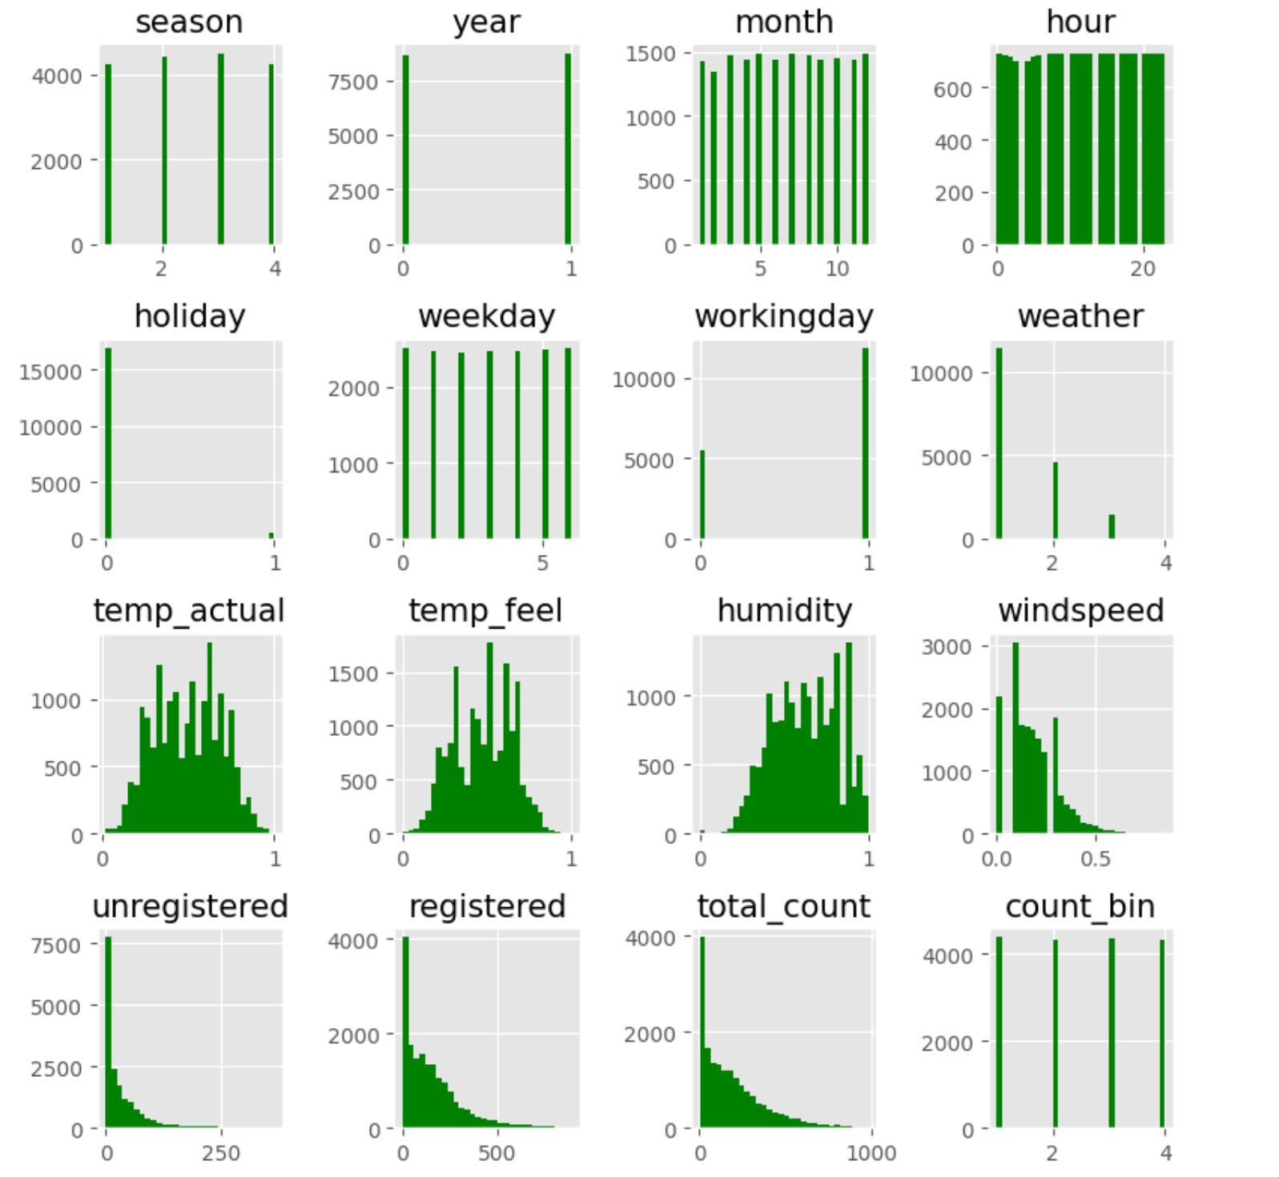

Figure 9- Attribute Distributions

As can be seen however, this wasn’t the most useful of visualzations as it really only gives us insight into how the columns are distibuted on a dataframe level. Therefore to better understand how those distibutions impact the target variable, the count_bin column mentioned before was used to view the same distributions but dependent on levels of rentals. An example of these distributions can be seen below where as the hue gets more red or hotter, it is indicative of the higher rental levels.

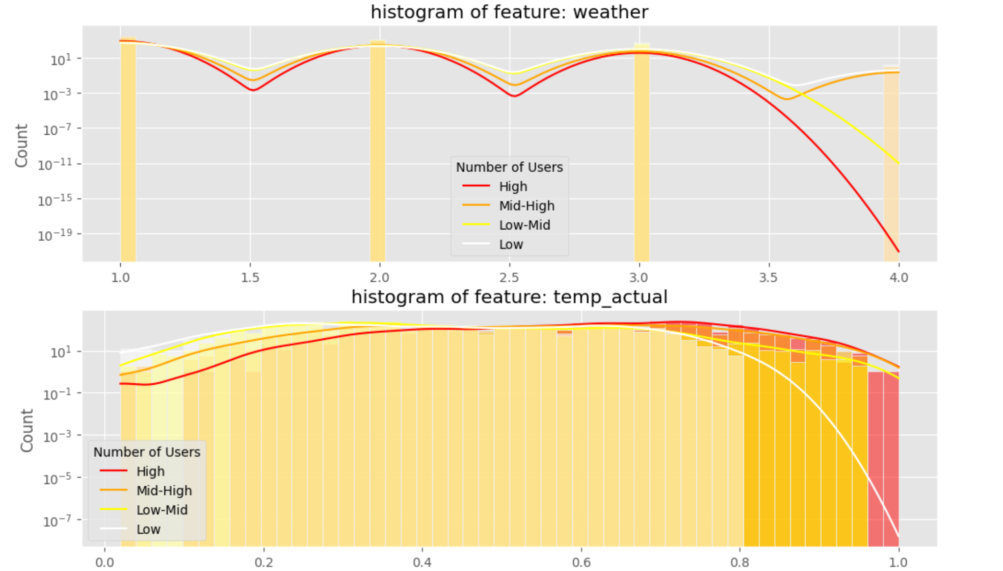

Figure 10- Weather and Temperature distributed showing Target

As can be seen in these cases, as temperature rises the records of low rental counts significantly drops off and as weather harshens the high rental counts drop off. These would indicate good predicter variables.

After visualizing all variables, the visualizations were narrowed in on specific predictors to visualize trends. First the different user attributes were plotted hourly.

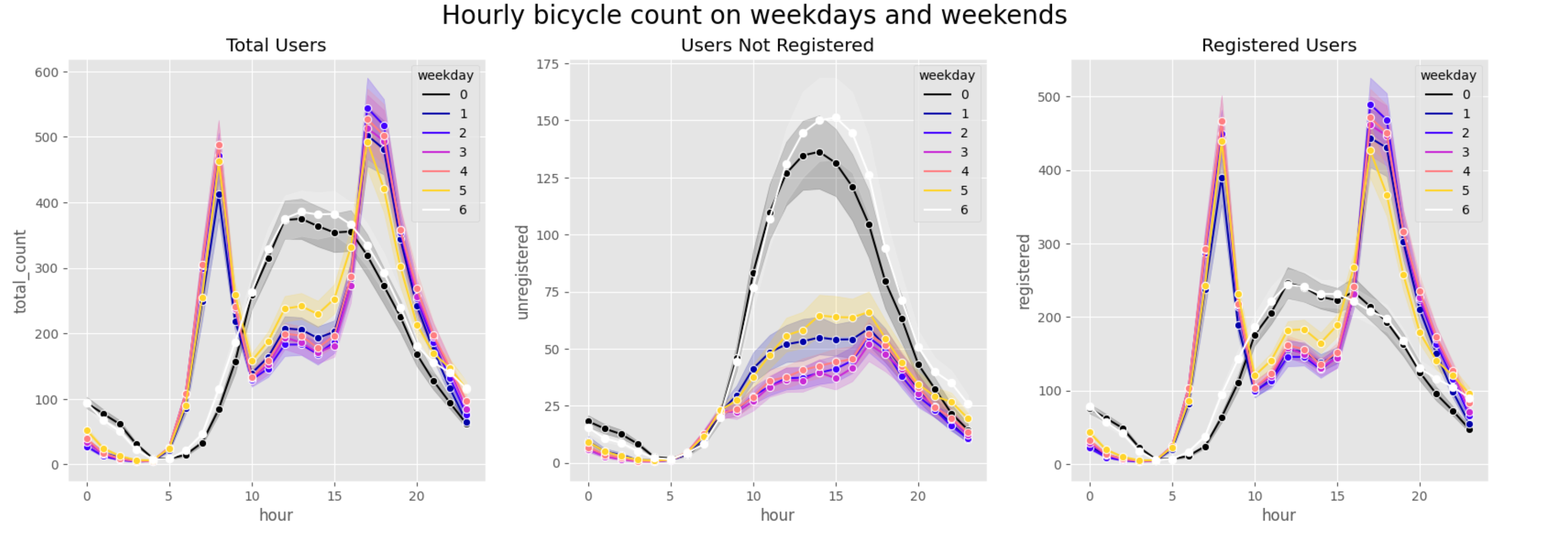

Figure 11- Rental Activity Hourly

Following this, the weather was visualized as well to see its effect on rentals along with distributions based on weekdays/workingdays.

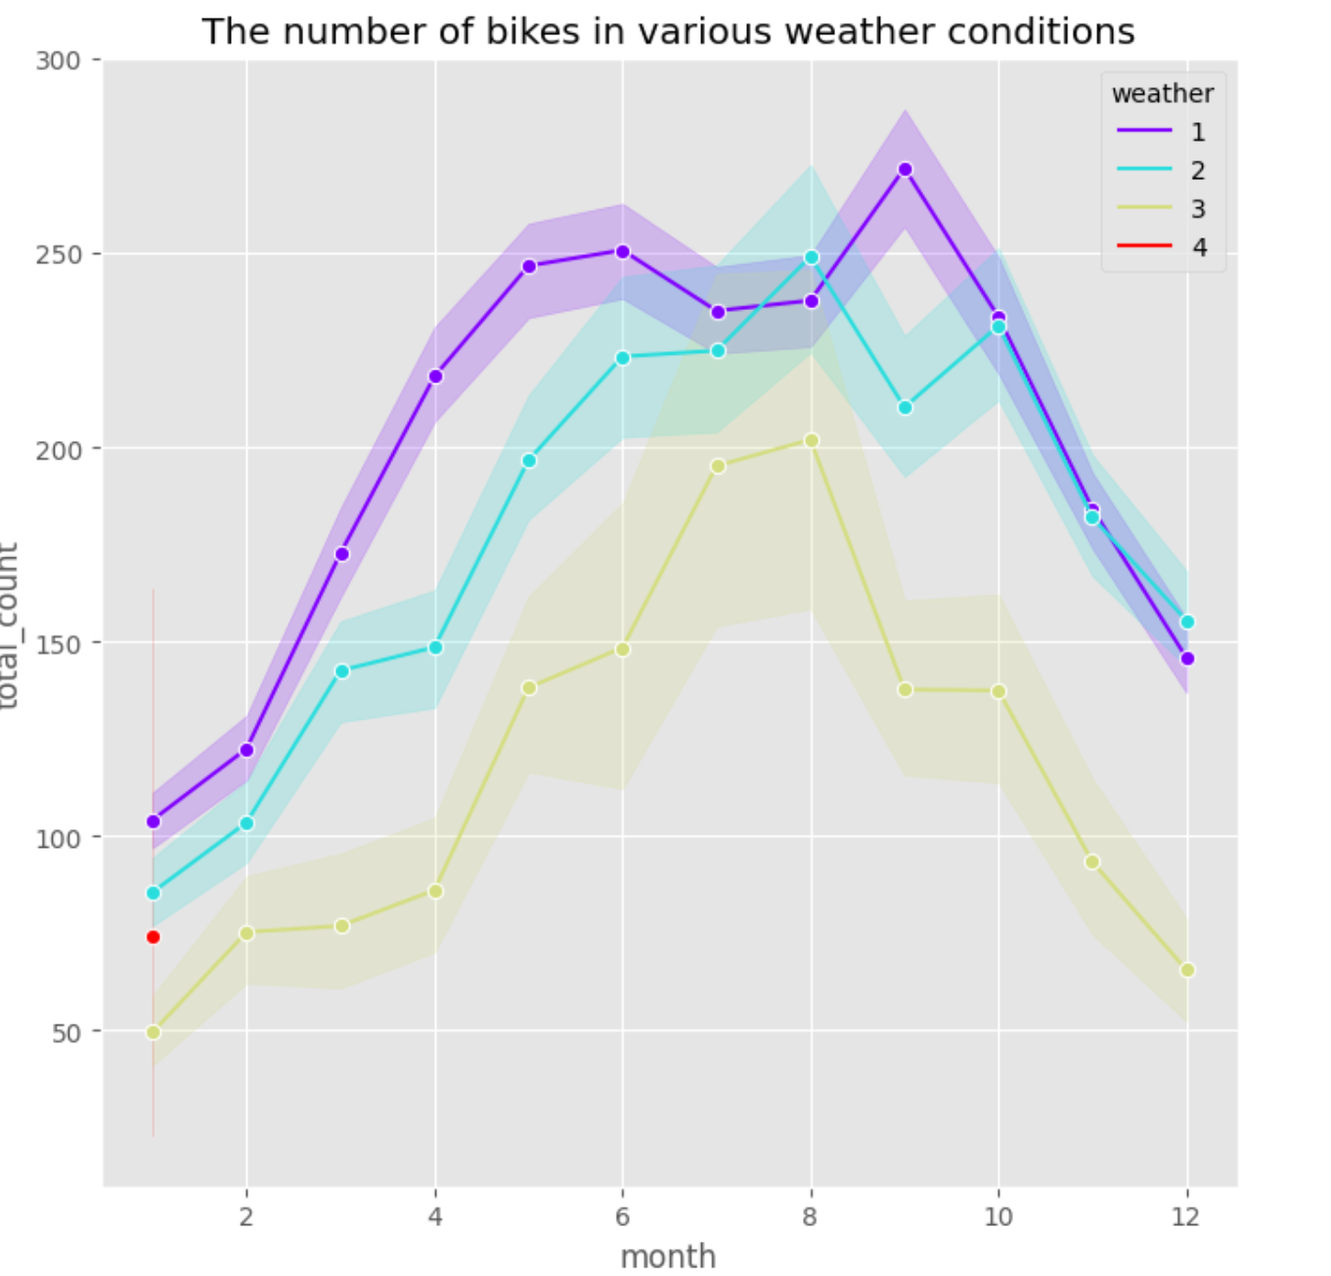 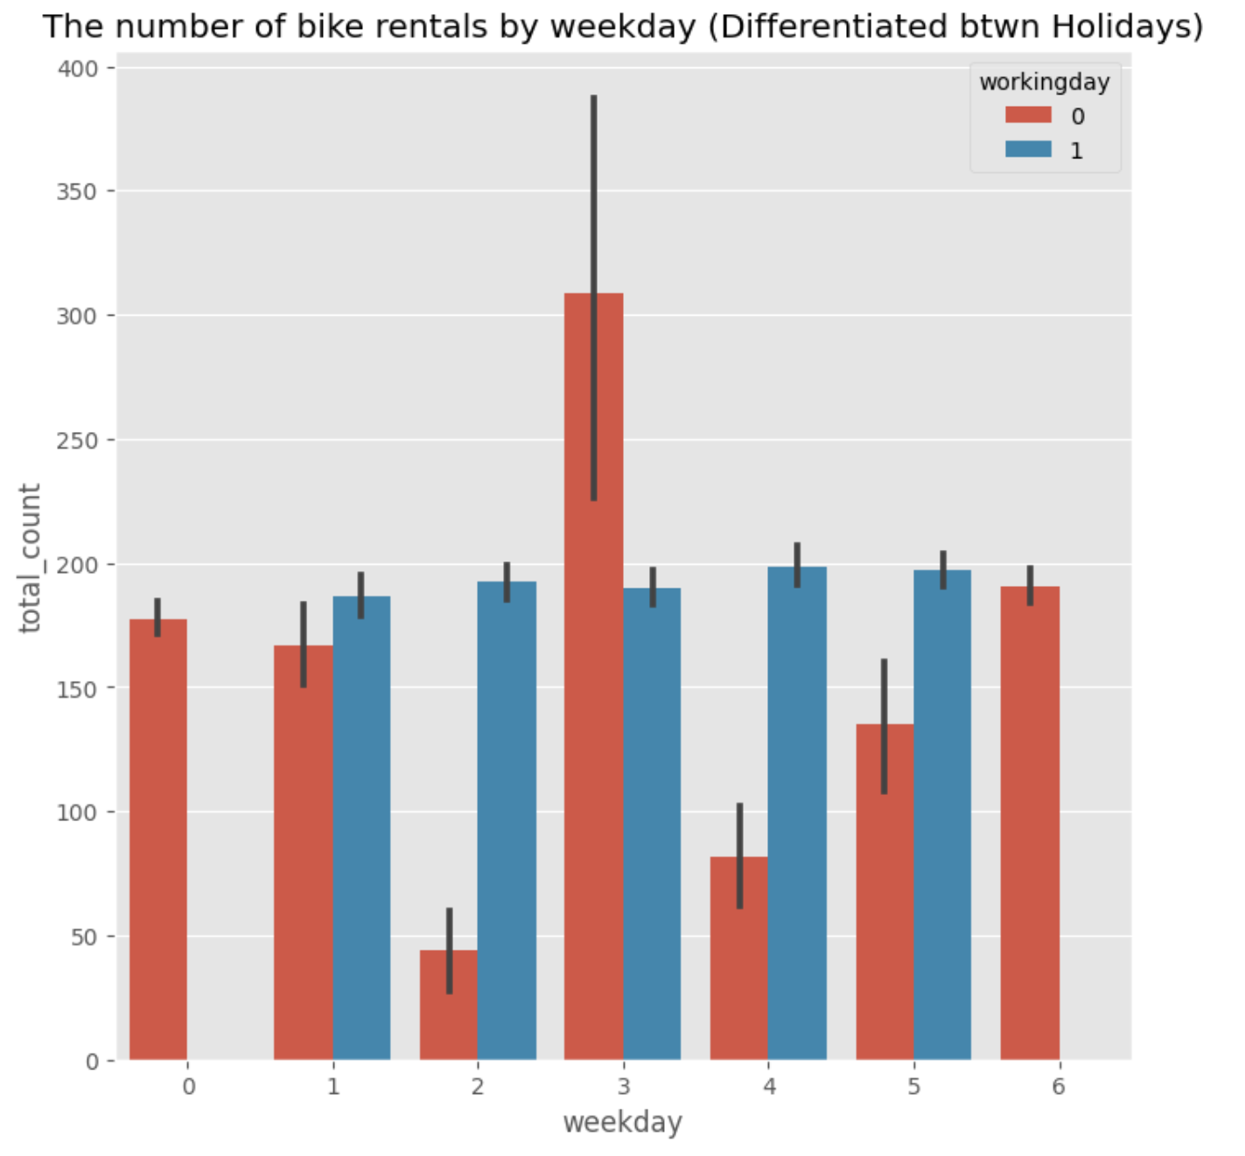

Figure 12- Additional Visualizations on Weather and Holidays

The distributions above show some clear discrepancies between weather forecasts and working intensive days which intuitively makes sense. Finally, with all of this in mind it was thought to be important to understand more about how weather affects bike shares. This was done as seen below but plotting a basic regression across all points bases solely on temperature, humidity, and wind levels.

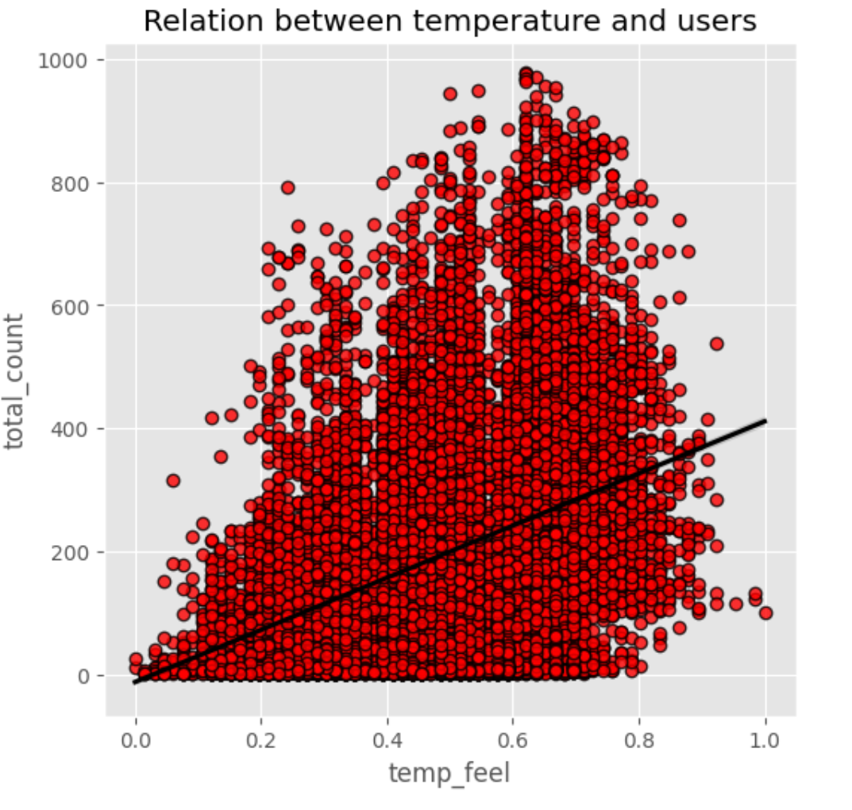 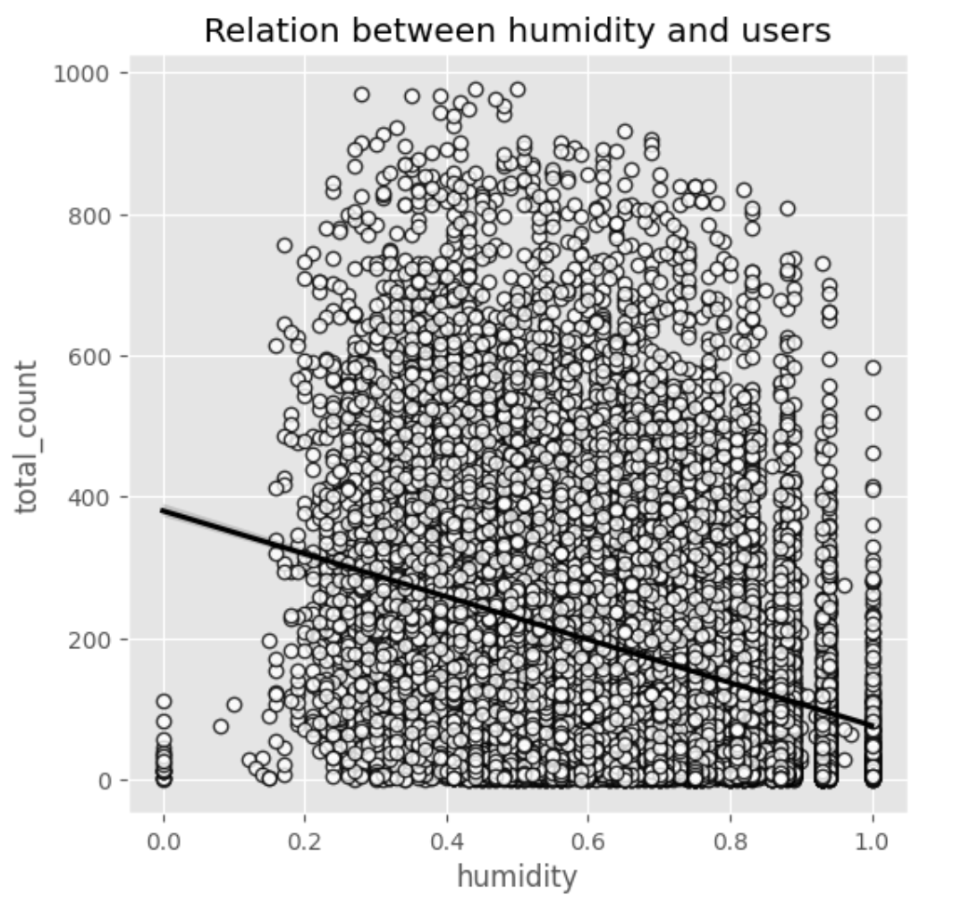 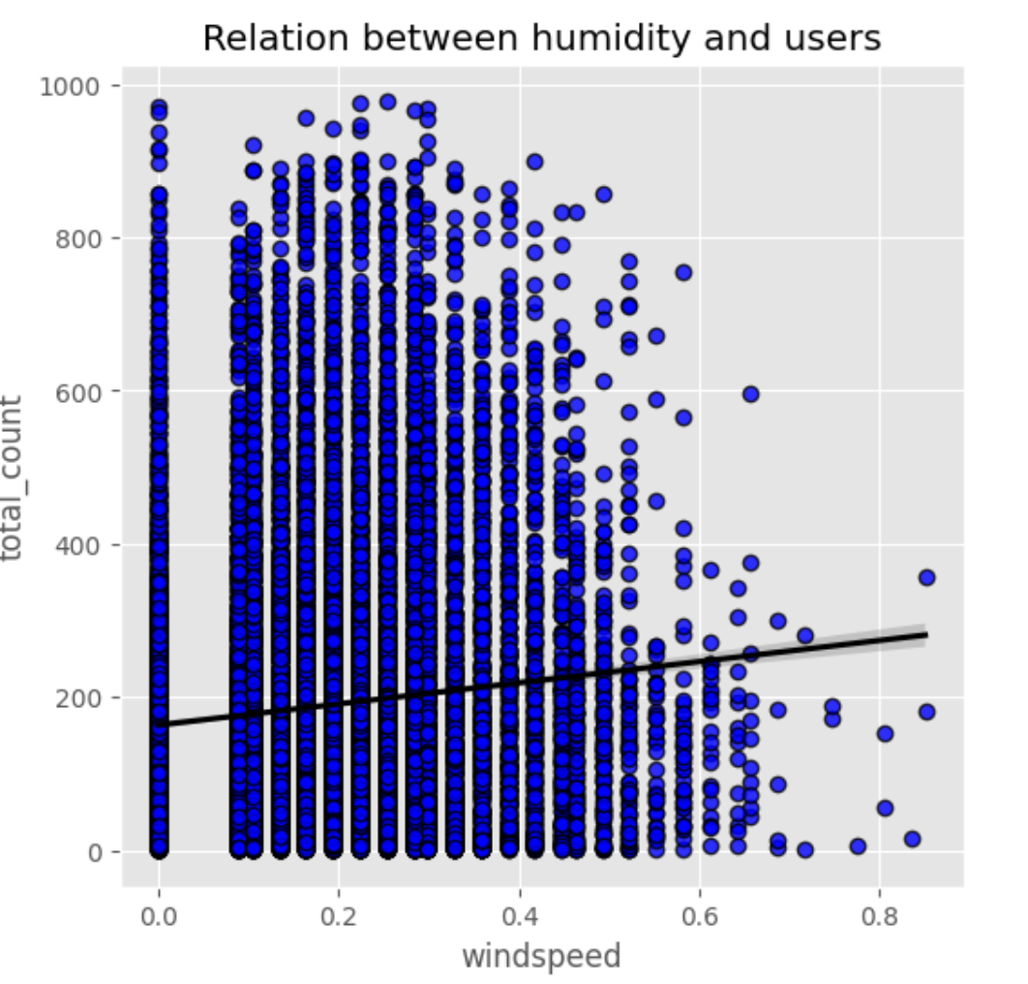

Figure 13- Weather Indicators vs Total Count Regressions

With this information and understanding that more predictor variables can prove useful, the temperature and humidity columns were combined in order to engineer a new feature representing a heat index score

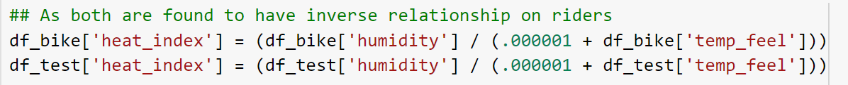

Figure 14- Code to Create heat_index column

# DATA MODEL METHODS AND RESULTS

After finally visualizing and understanding the data, the project could move into the main aspect of satisfying the objective, predicting bikeshares. First, the correlations of each attribute were viewed, and overly correlated columns were removed. This was not discussed above because after a very iterative approach to training the regression a few main results were determined which illustrated that it could be useful to leave them in the dataset to illustrate overfitting. That correlation matrix can be seen below.

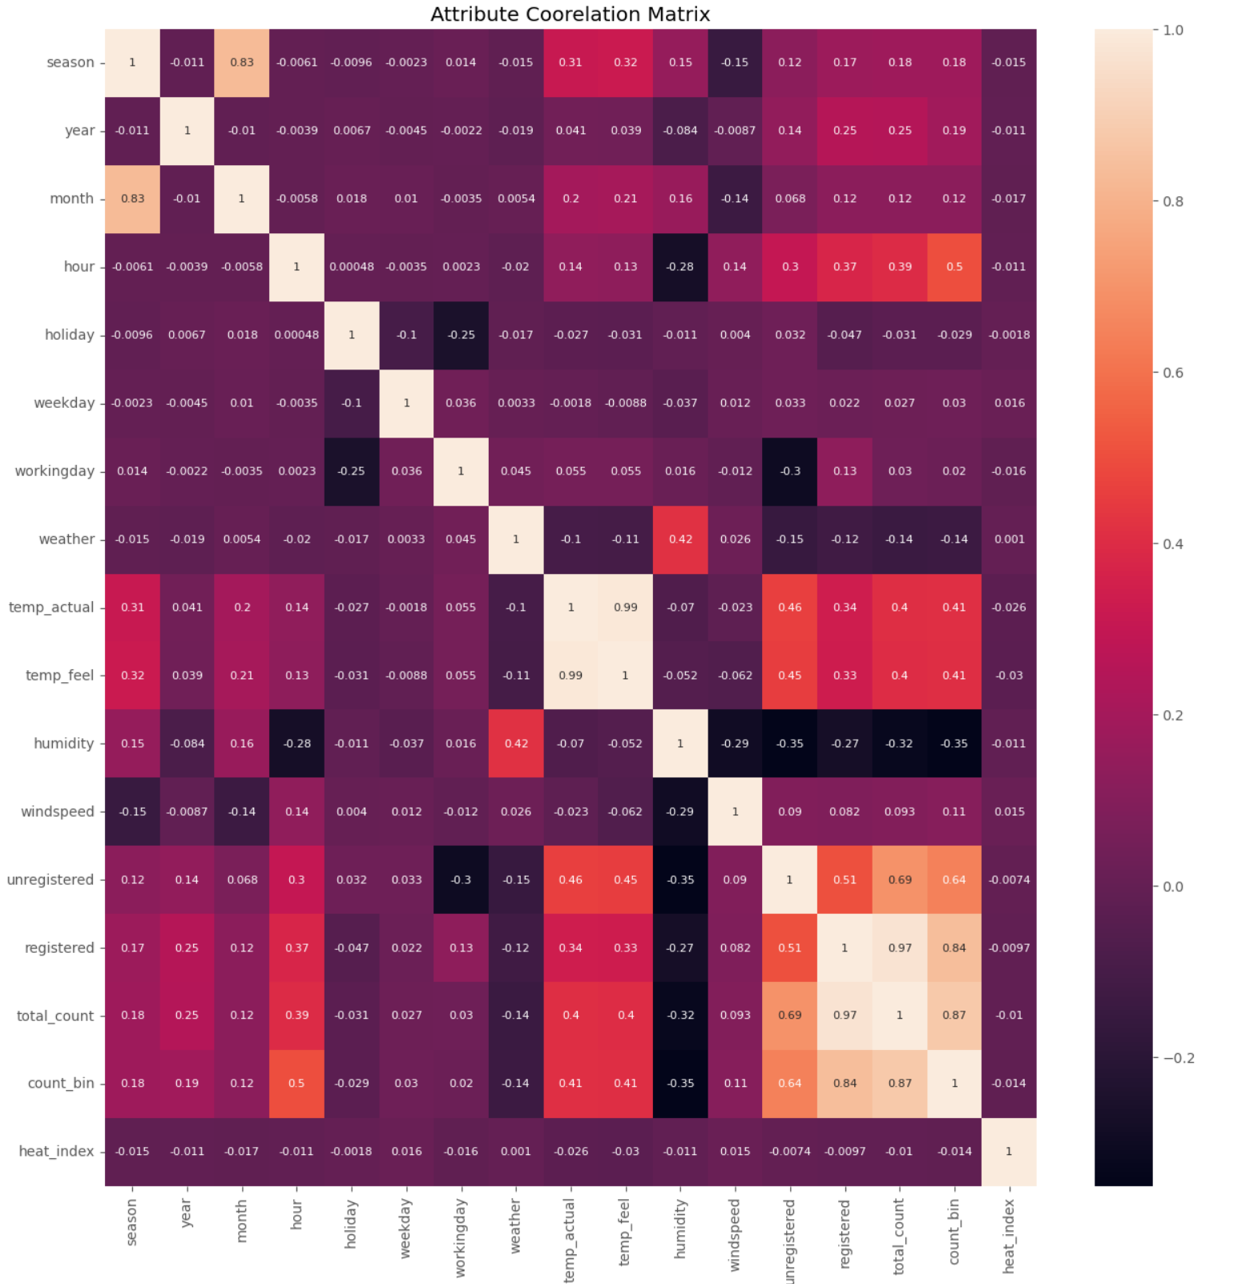

Figure 15- Correlations of Data Attributes

It can be observed that the columns which were to be removed (over 0.9 correlation) were registered users and temp_actual as total_count and temp_feel are nearly identical. These were kept as previously mentioned to help in the baseline model. 3 separate datasets were used for training to visualize different things about statistical and machine learning. Those datasets are as follows:

Df_bike_baseline and Df_test_baseline – The baselines are as mentioned the entire datasets including engineered columns and overly co linear attributes like those which should be removed from the correlation matrix.

Df_bike_historical and Df_test_historical – Removal of all multicollinearities however under the assumption that historical data like the attributes provided including unregistered users are available.

Df_bike_limited and Df_test_limited – The bare minimum information including just dates and times as well as weather. No prior knowledge of historical rentals

## Linear Regression

Utilizing these datasets, the Linear Regressions could be trained and evaluated but first a bit about the Regression. Regression is a way of modelling to predict a continuous target variable. It is not as straight forward as maybe classification since the model is being trained to predict from a wide range of values (theoretically infinite) based on learning the relationship between the independent predictor variables and the dependent target. The aim is to find the best hyperplane which describes the relationship between the attributes and the outcome. As will be discussed this was coded from scratch with the option to perform a variety of alterations. The alterations stem from a variety of things such as penalization (regularization), gradient descent, stochastic or mini-batch, as well as cost function error types and many others. The code is formatted to allow any model chosen to be tested.

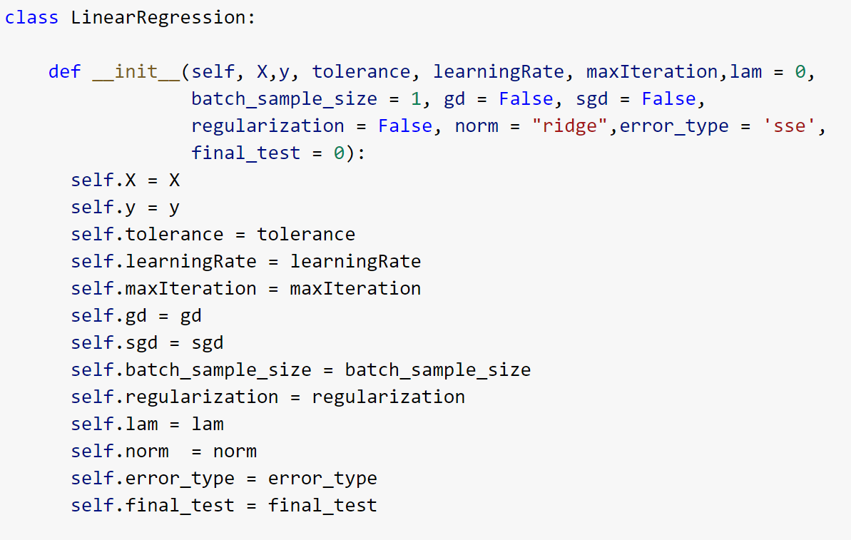

Figure 16- Linear Regression Class

### Closed Form Solution

First the closed form solution or the baseline equation of Linear Regression was used to visualize the three aforementioned dataset trainings. Closed Form is in its essence the simplest and quickest way to solve for weights. It is simply found through the following formula which is centered around matrix multiplication and linear algrebra:

$$∅={(X^{T}X)}^{-1}(X^{T}y)$$

Where X is the input data, y is the known target and theta is the weight to solve for. This equation is the backbone of linear regression and was used to find the plane quickly. At this stage Closed Form was used to show the aformentioned differences between the baseline data, historical data and limited data. It illustrates the overfitting previously discussed and leads us to the next step. As can be seen, the baseline model has an R^2 value of 1.0 which is essentially impossible and is due to the concept of overfitting. The model was trained so well that it learned every little thing about that data and perfectly traced it. Therefore, if using another dataset, the results would be horrible (see below figures).

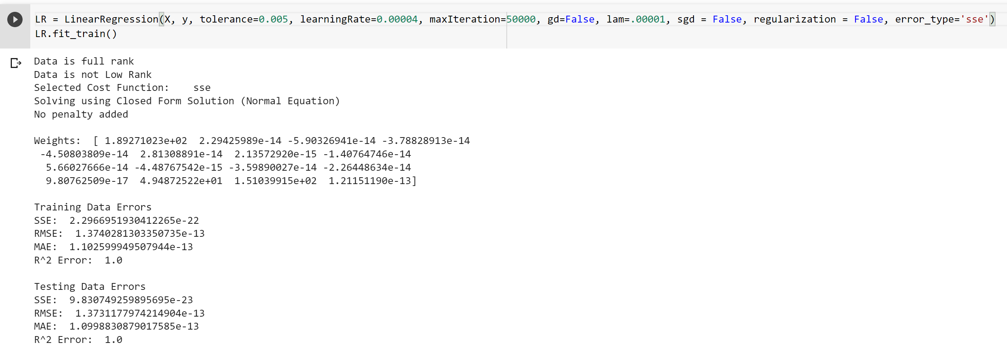



Figure 17- Baseline Model: Overfitting

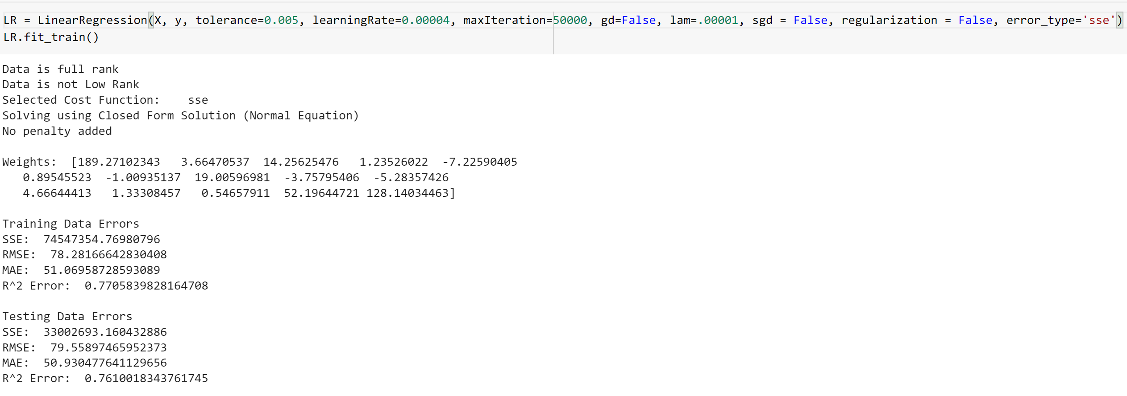

Figure 18- Historical Model: Utilized

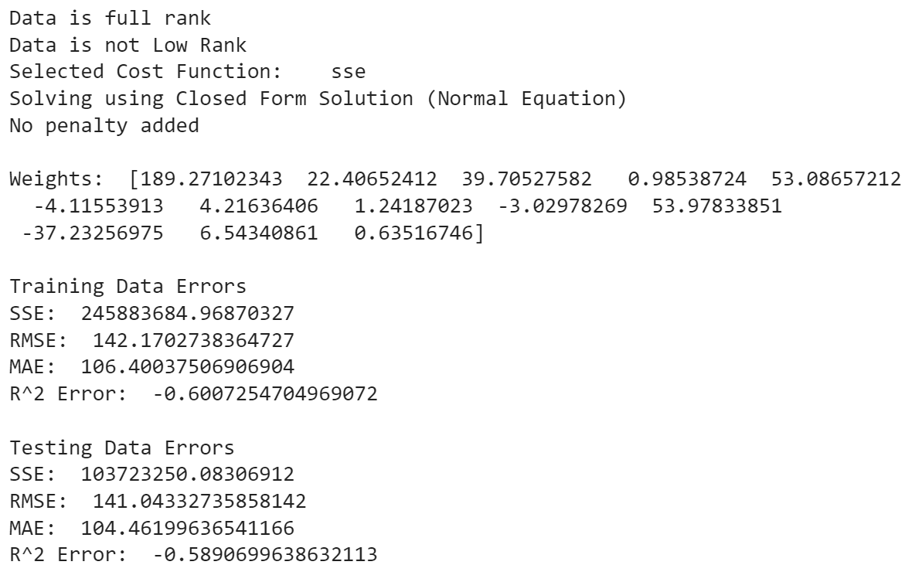

Figure 19- Limited Data Model: Low R^2 so not useful for other data

Fortunately, this was done through a method called Hold-Out testing. As mentioned throughout the report, there were two initial datasets, one hourly and one daily. The daily dataset was preprocessed identically to the hourly one and was labeled by df_test. This was utilized as the final Test Set in hold out testing. The process of hold out testing assesses the future use of the models being trained and as can be seen below, the overfit model performed terribly on the new set of data using the weights learned. It should be noted that this hold-out testing has imperfections due to differences in data as it has no hour information and so that weight was not used. In the real world this is not ideal and wouldn’t provide the best results but for the purposes of displaying the understanding of hold out testing it was used here.

Another observation to mention are the downfalls of Closed Form Solution. Namely, the data must be Full Rank which was accounted for in the code. Additionally, the closed form solution is not the best way to solve for weights especially with such a large dataset and could have implications on the results. Finally, Closed form is very expensive to implement especially with such a substantial amount of data.

That being said, the historical model was chosen to utilize moving forward as it had the best r^2 value that was not indicative of overfitting like the baseline was. At this point, a variety of models were done to illustrate the effectiveness of the LR model outside of Closed Form as will follow in the next section.

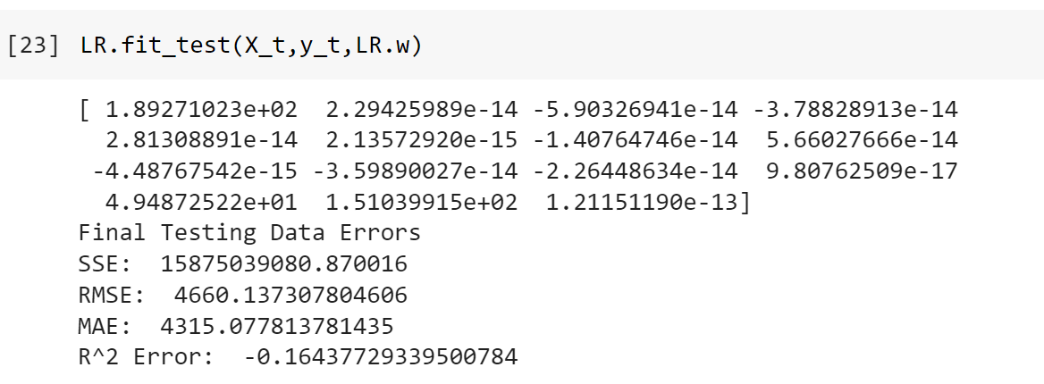

Figure 20- Hold-Out Testing Results

### Gradient Descent

These included Normal or Batch Gradient Descent, Stochastic Gradient Descent, and Mini-Batch Gradient Descent all with and without regularization terms. Gradient Descent is a method of optimizing the weights by minimizing a cost function or loss function. It is an iterative process where each iteration error is calculated and compared to previous iterations. If there are improvements the algorithm continues in its descent to find the lowest or minimal error and does so until a tolerance is reached, the maximum number of iterations have been performed or the model error is not decreasing substantially. Batch Gradient Descent performs this process on the whole training data which can be costly but effective. Stochastic Gradient Descent is a similar if not identical process however each iteration is done on a single sample of training data thus each iteration takes longer as the sampling must be done every time however ideally the model should converge to an optimal set of weights faster. The other model attempted was Min-Batch Gradient Descent which as the name suggests is a common place between Stochastic and Batch where a sample of specified number of records are used to perform the descent each iteration and thus follows the same patters as stochastic but even slower per iteration.

In addition to the different types of GD, regularization parameters as previously mentioned were used. These provide a penalty which can combat issues with overfitting and since no outlier removal was performed, this was an important step to have to avoid such problems. There are two regulations or Norms used in this project. L1 or Lasso and L2 or Ridge regressions. They are defined by the below equations.

L1 = ${\sum_{i=1}^{n}{| ∅}}_{i}|$ L2 = ${\sum_{i=1}^{n}{∅_{i}^{2}}}_{}$

L1 and L2 both place large penalties on the gradient descent process to avoid overfitting. L1 gives equal importance to every feature and L2 penalizes the feature coefficients. Both help to avoid overfitting which is a main concern with Linear Regression. The following figures show examples of some of the results starting with no penalties for all three GD’s followed by batch or normal GD with ridge regression.

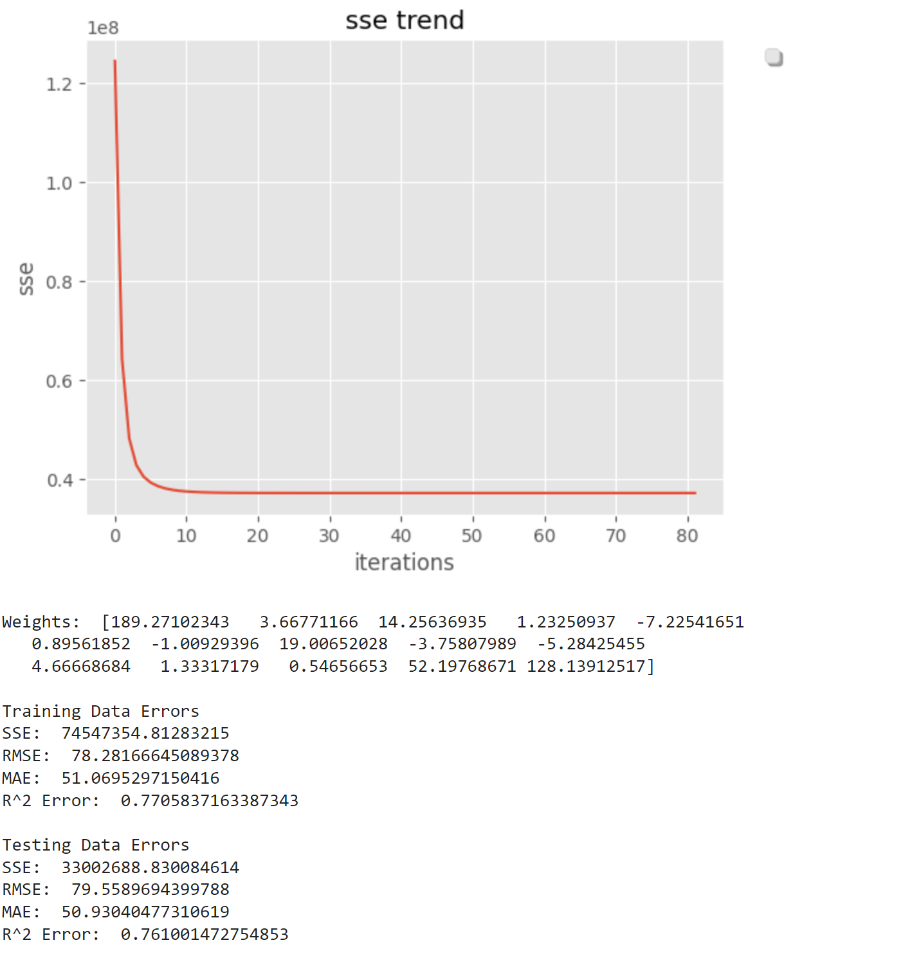

Figure 21 – Gradient Descent No penalty

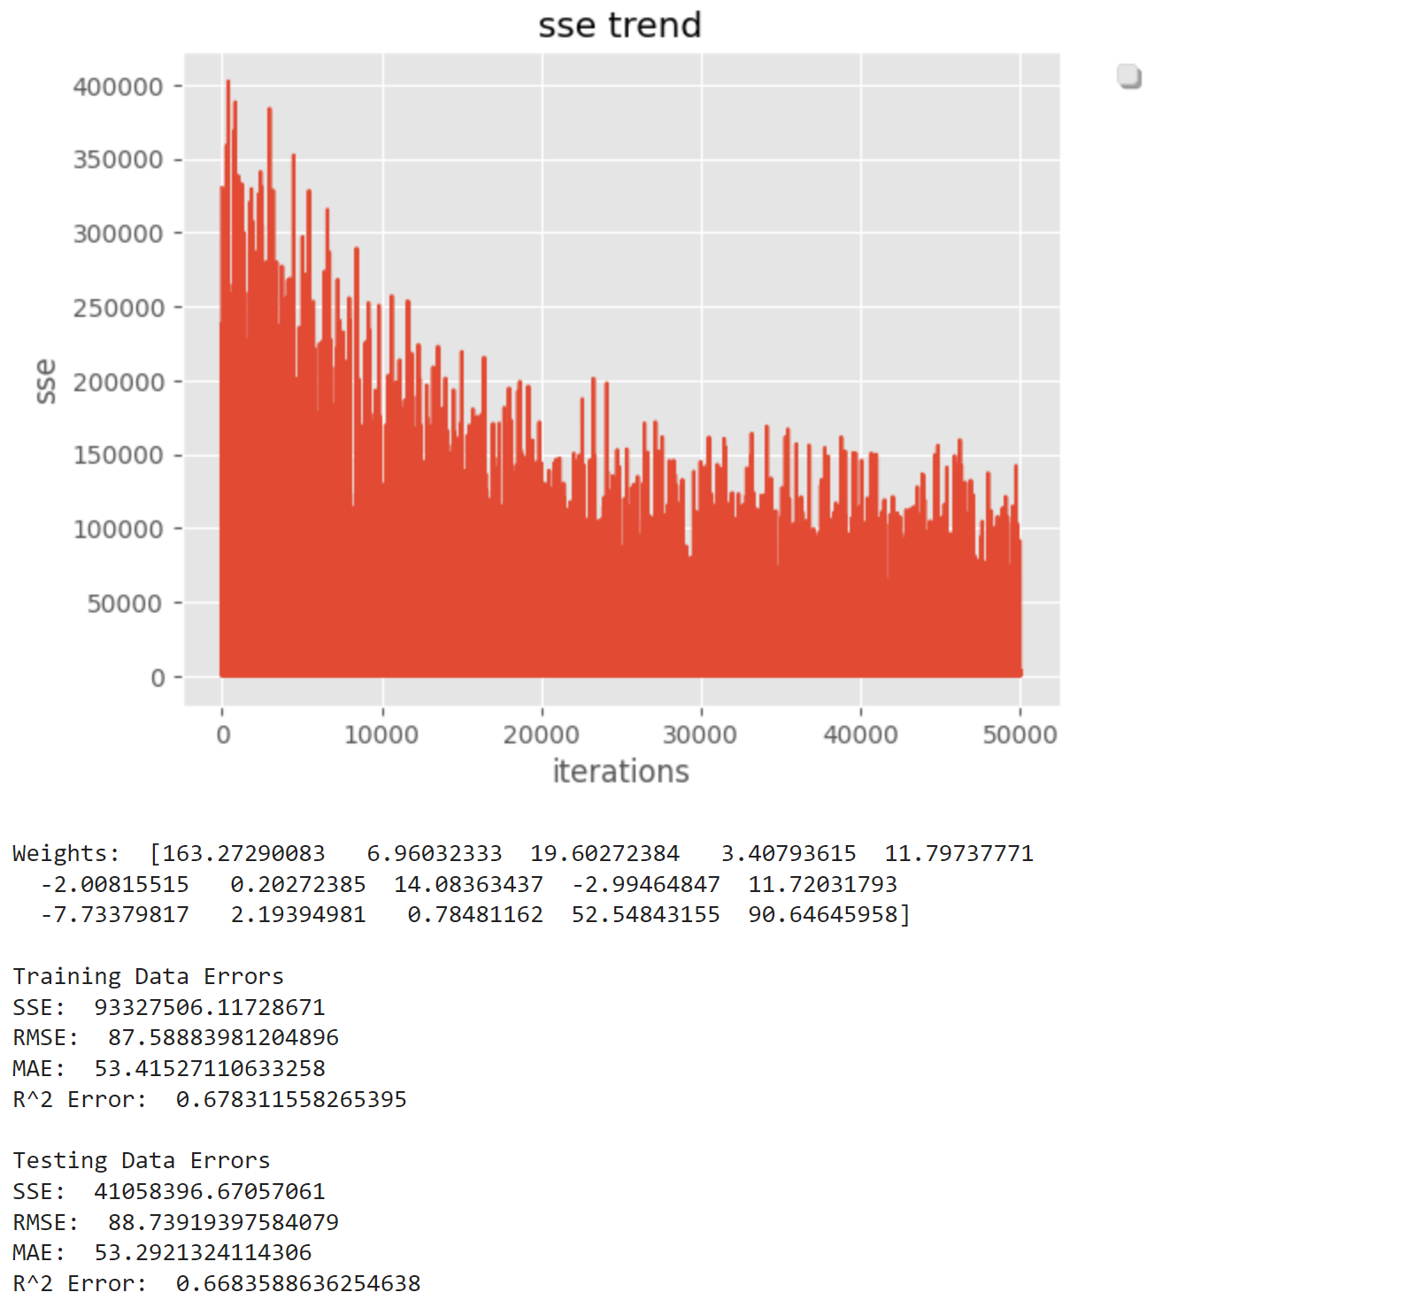

Figure 22- Stochastic GD No Penalty

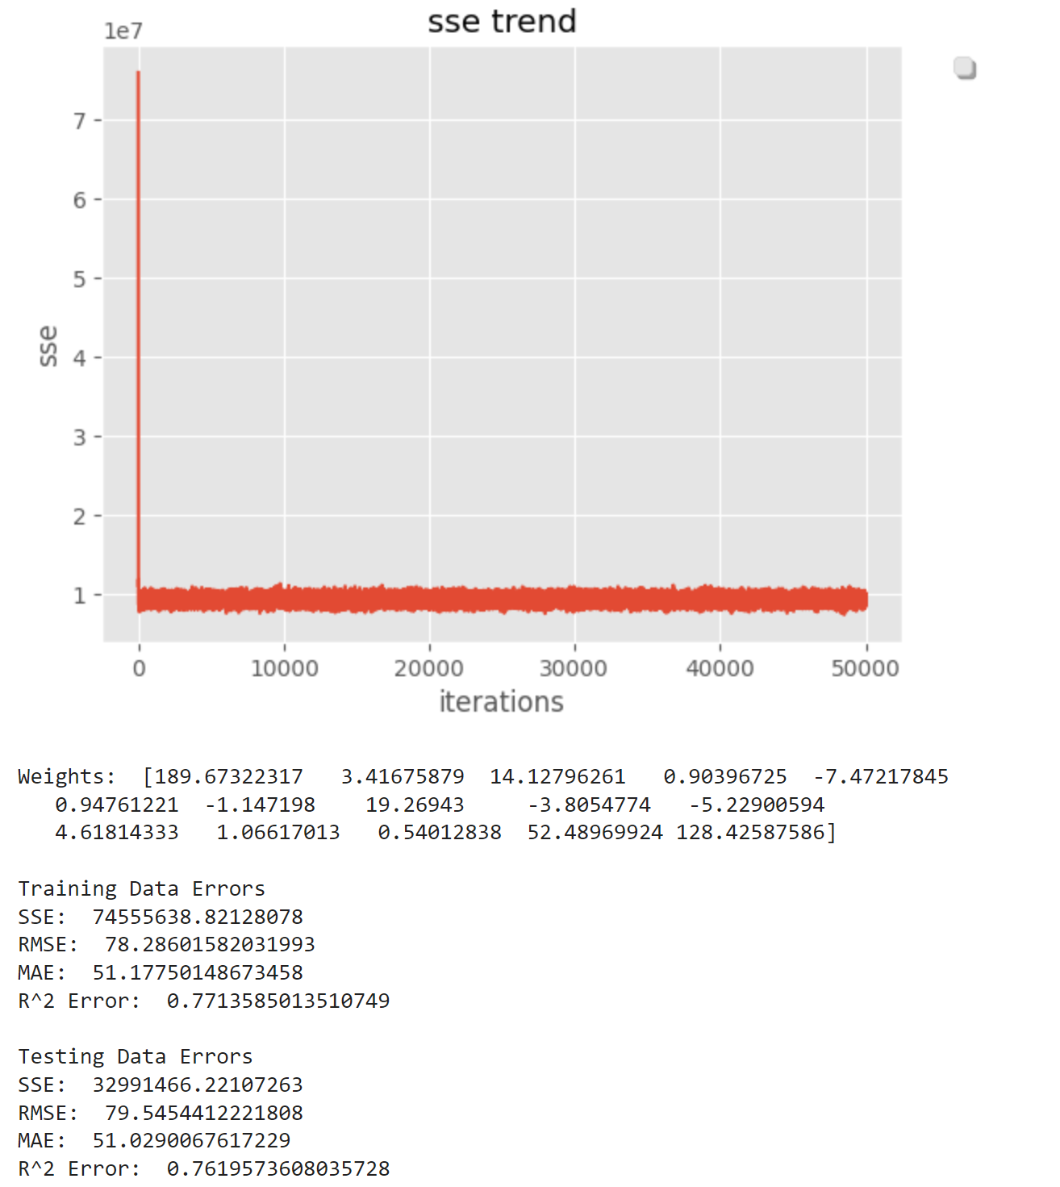

Figure 23- Mini-Batch (.25 of data) no penalty

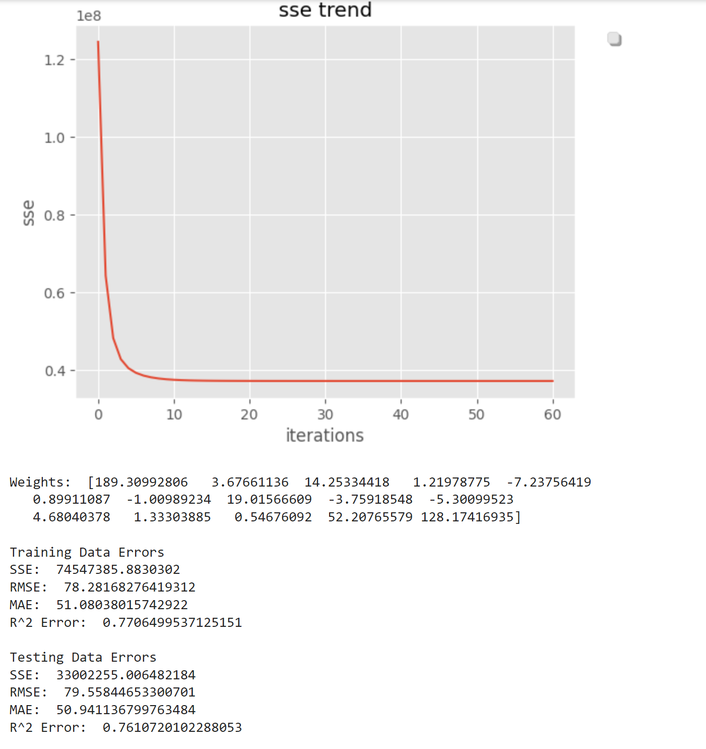

Figure 24- Batch GD with L2 Norm

As can be seen the results are fairly as expected. However Stochastic and Batch Gradient Descent do take more iterations. This could be due to unoptimized parameters but more likely is due to the type of data. Hourly data is very up and down as well as random and therefore has substantial variance. Combined this with a model that automatically has large variance due tp recalculating samples every iteration and hence the reason why it takes so many iterations. That being dais the results are still comparable across the board and mini-batch actually provides the lowest rmse and mae values.

Another big takeaway here is the comparable results for normal GD and GD with L2 implemented. This shows that the initial model is not overfitting much and there is no multicollinearity.

Some issues that arose and were plotted to prove are the stochastic gradient descent when a penalty is added. Combining the high variance issue from before and potentially very too large or unoptimized lambdas the below plot can be made where essentially the model tried to converge but kept taking jumps that were too large. As can be seen in the lambda value is made bigger it becomes worse and smaller improves.

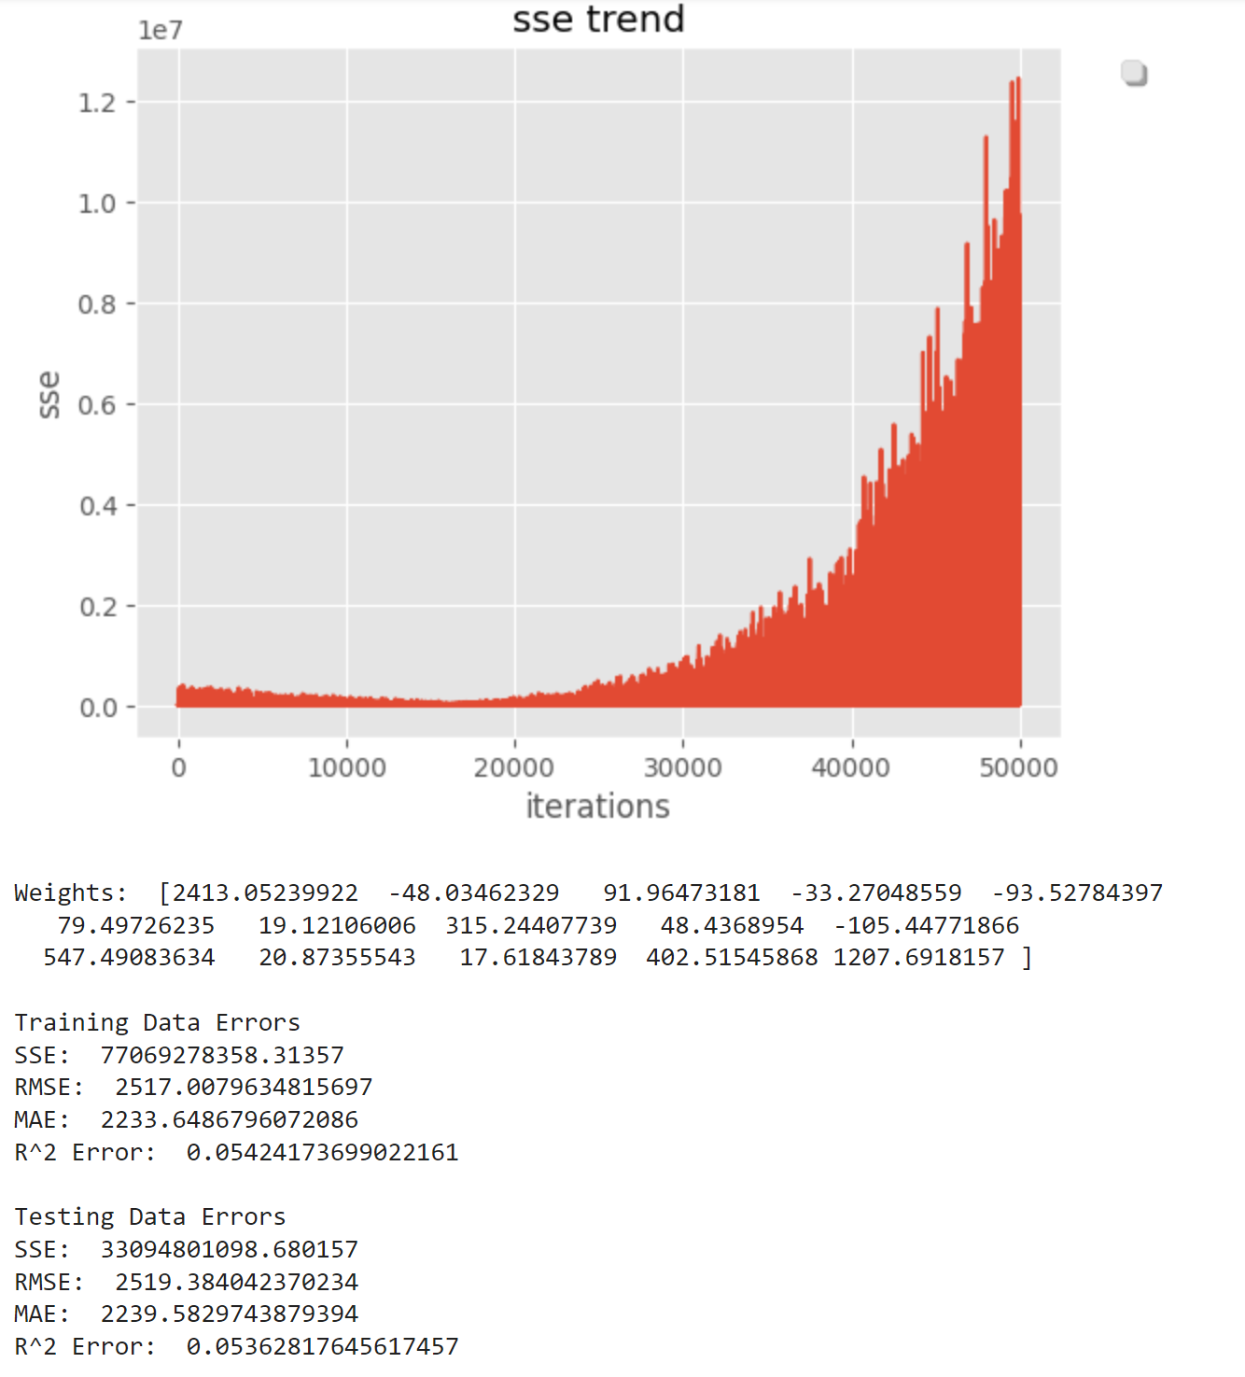

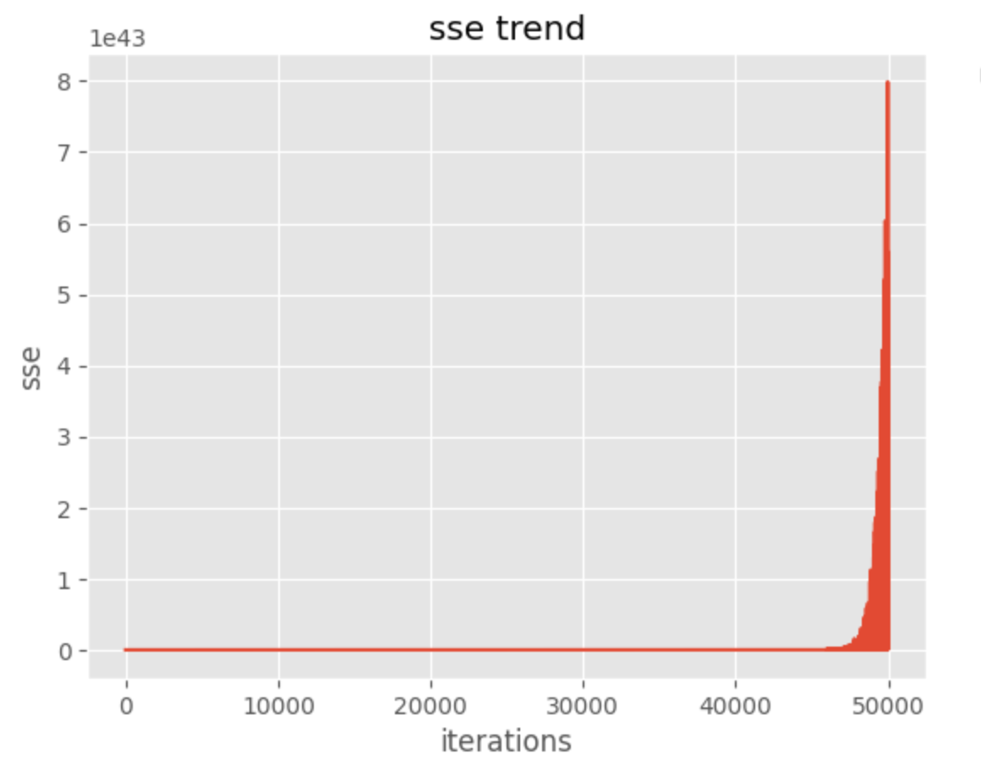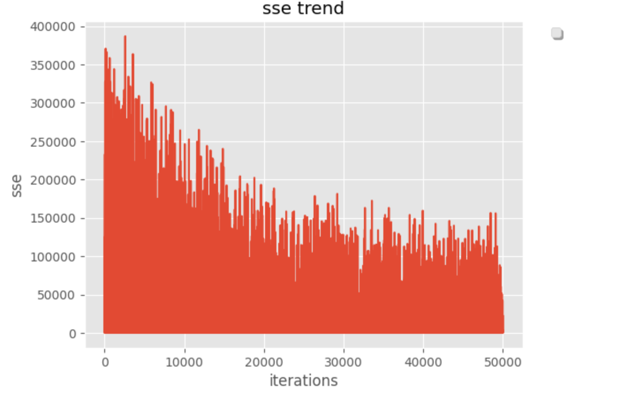

Figure 25- Issues that can come from high lambda (lambas = .0001 .01 .00000001)

Another thing looked at was the cost function as can be seen below. The results show that while sse or mse is the most commonly used cost function, results can be improved if using other error or loss functions like rmse.

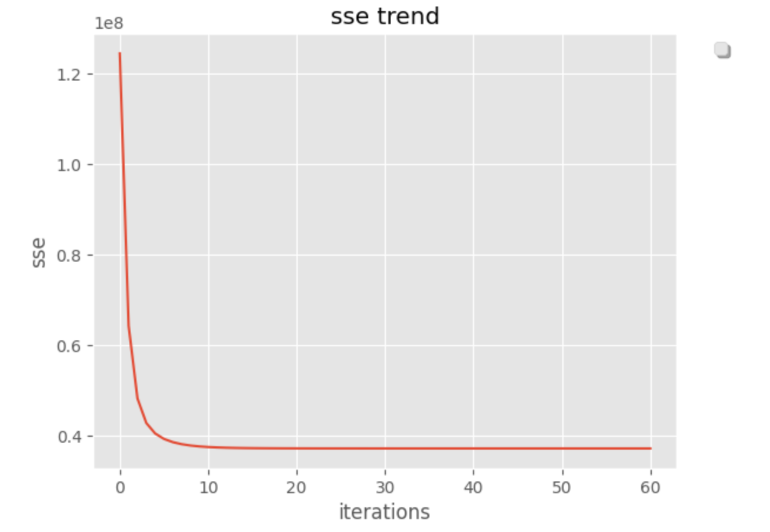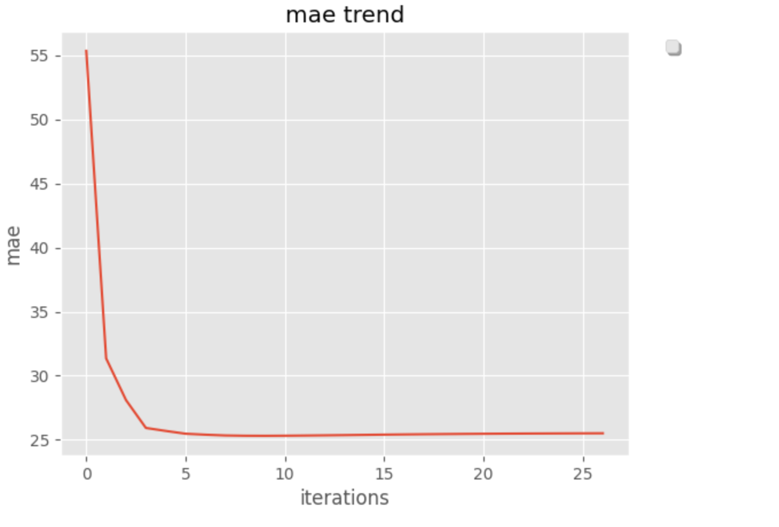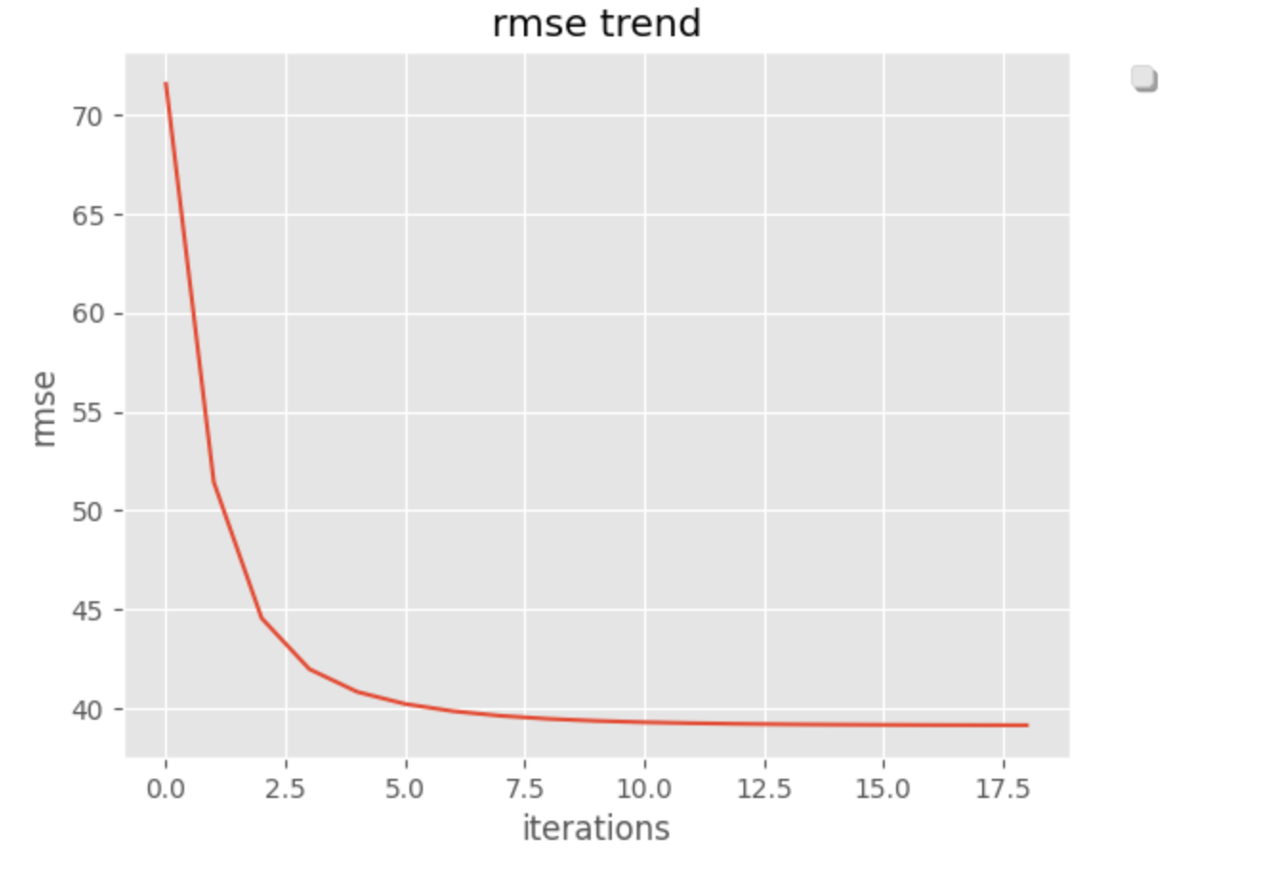

Figure 26- Varying the Cost Function

Finally, one more thing illustrated in this portion is what would happen if training on the daily dataset. The results are not surprising as the model actually provides better r^2 error. This makes sense as the data has less variance to cover and thus the model is able to train and cover a majority of the variance of the data. This could be useful moving forward.

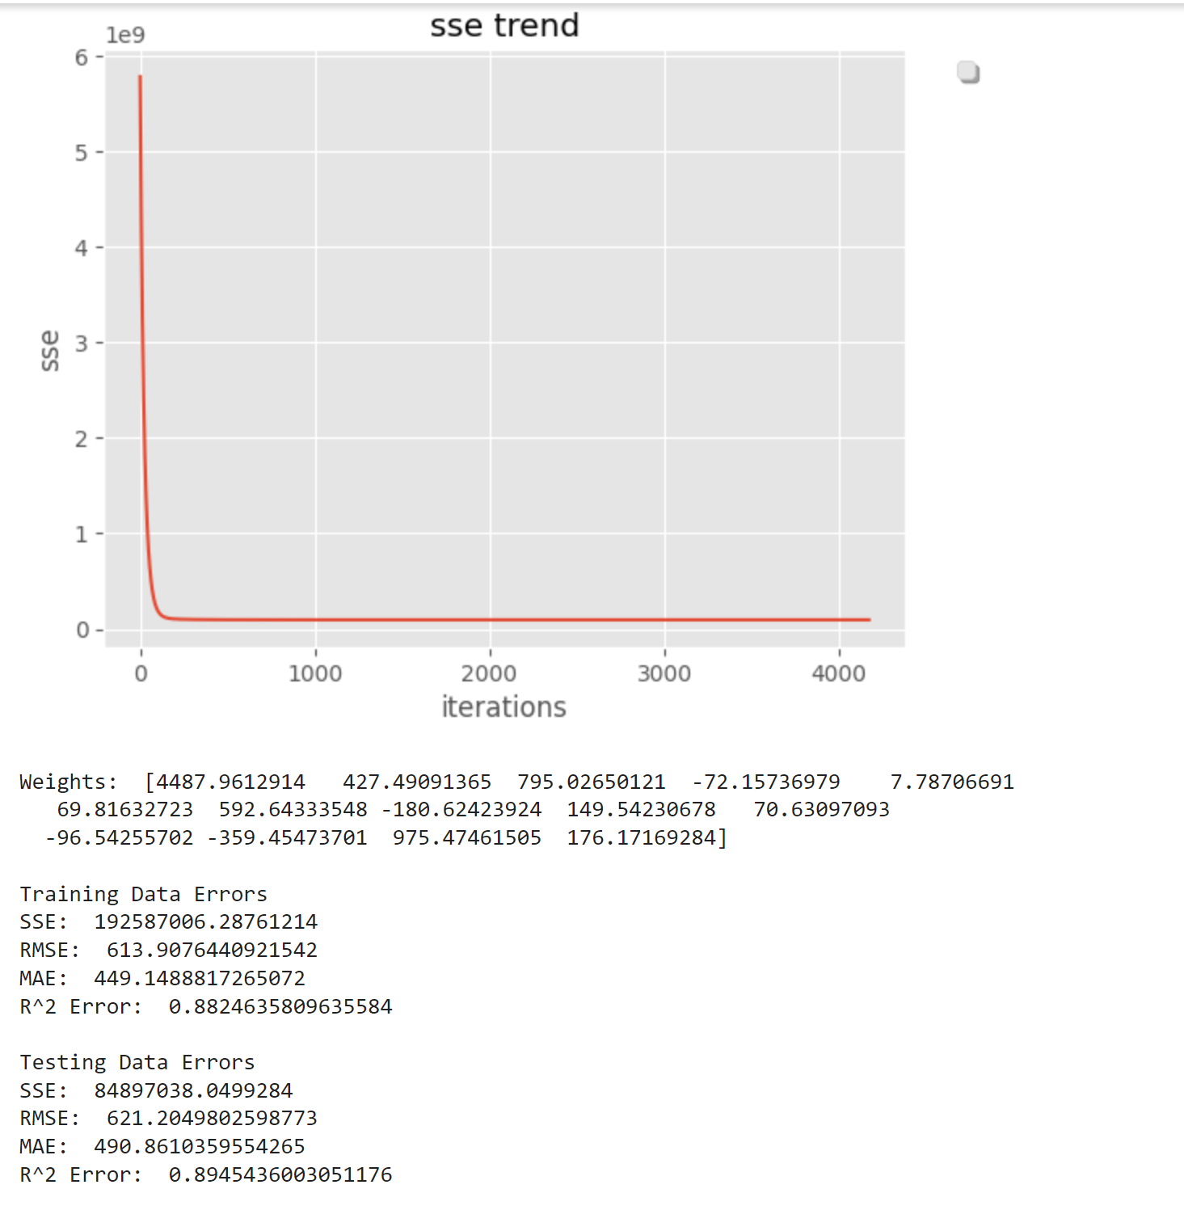

Figure 27- Training on Daily Rentals

## Neural Network

Next, Neural Networks were implemented as well or attempted for that matter.

Three components make for a simple neural network:

**a) Input Layer:** - The inputs/information from the outside world that are given to the model to learn from and draw conclusions from are also known as input nodes. Information from input nodes is passed on to the hidden layer, the following layer.

**b) Hidden Layer:** - The group of neurons in the hidden layer are where all calculations on the input data are made. A neural network can have more than one or N number of hidden layers in it. One hidden layer makes up the simplest network.

**c) Output Layers:** - The model's output are found in the output layer and are the result of all calculations. In the output layer, there may be a single node or several. When dealing with a binary classification problem, the output node is 1, however when dealing with a multi-class classification problem, the output nodes might be more than 1.

Performing Neural Networks Involve Following Steps: -

a) Input units are passed in the initial phase. Data is given to the hidden layer with certain weights applied, for example. There might be countless hidden layers. The inputs x1, x2, x3,...., xn.

b) Neurons make up each buried layer. Each neuron is wired to receive all inputs.

c) The hidden layer is where all calculation is done once the inputs have been passed.

d) Each concealed layer goes through the whole procedure outlined in point 3 of that paragraph. We proceed to the last layer, our output layer, which provides us with the ultimate result, after passing through each concealed layer.

e) The error, or the difference between the actual and expected output, is determined after receiving the predictions from the output layer.

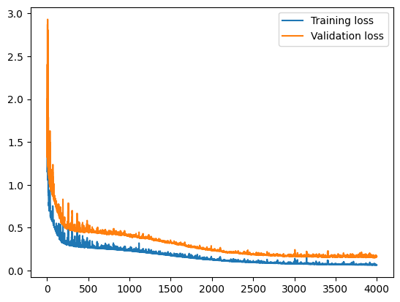

Figure 28 – NN Training and Validation Loss

As we can see the Training and the validation loss are almost overlapping each other

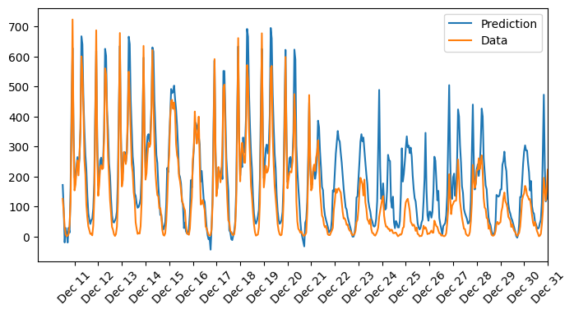

Figure 29- Prediction vs Actualas Data

We can say that the model is running at its best accuracy as the Prediction

and the data are almost overlying each other.

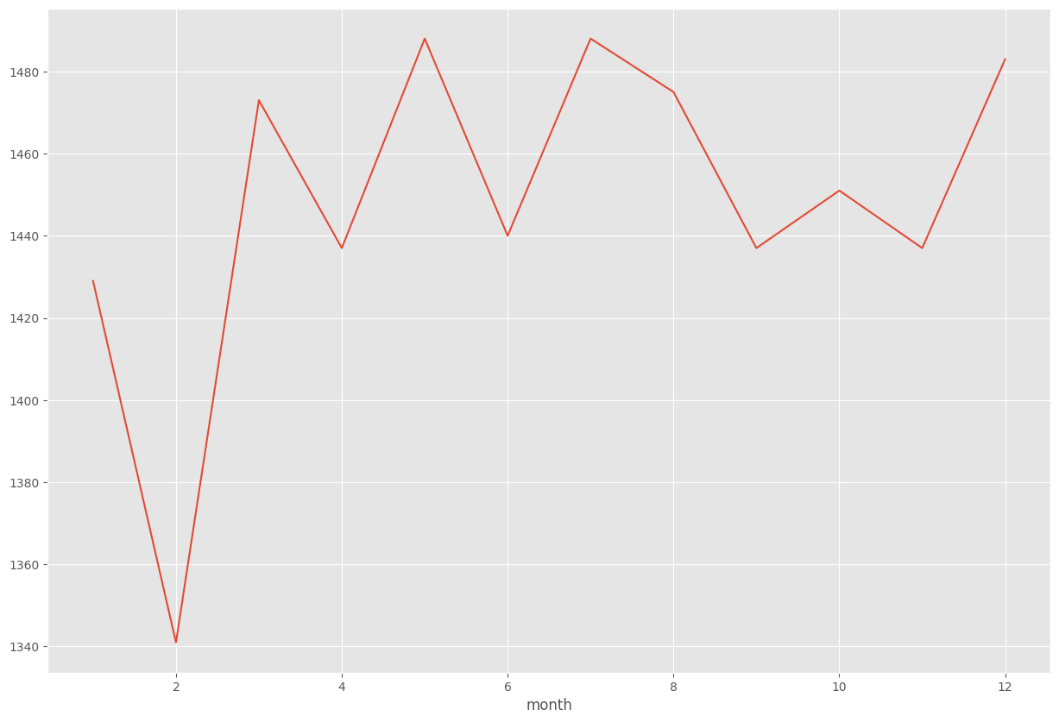

Figure 30- Total count as training example month wise

# CONCLUSION

In conclusion, a very wholistic view of regressions and predicting continuous variables was accomplished through this project. As we know bicycle rental shares are an ever-growing opportunity to reduce our carbon footprints and it is in our best interest to invest in being able to predict trends in this field. That being said, while the results in this project present an academic understanding of regressions and some promising results there is still a great deal of work that could go into improving these models including further feature engineering, parameter optimization and model exploration.

Overall, however, the models illustrate the very essence of Regressions through hold-out testing, error assessments, understanding regularization and exploring closed form and gradient descent types. Weather data is often heard to predict especially on an hour-to-hour basis but through the methods implemented here Neural Networks, Batch and Mini-Batch Gradient Descent show a great deal of promise. Rmse Cost Functions show good results as well and if other parameters are further optimized the results can improve even more. Additionally, the concept of Bias and Variance can be seen from the models which illustrate overfitting or high variance, this is a very common occurrence in linear regression and even more so from such a variant dataset like hourly weather data. All of that being said, through the methods aforementioned including substantial data engineering, feature reduction/engineering and regularization both the overfitting seen in the baseline model (high variance) and the underfitting (high bias) seen prior to feature additions such as heat_index could be combatted. Thus, the project objective was succesfully accomplished and moving forward the models could be further optimized to be useful in a time where we need bike shares even more than ever.